Local DHCP (IP Address Pools)
When using a local DHCP server and issuing an IP address to a subscriber via Framed-Pool, the fastDPI, fastPCRF, and KEA modules must operate within the same local server.
SSG supports IP address pools for DHCP Radius Proxy and PPPoE modes.
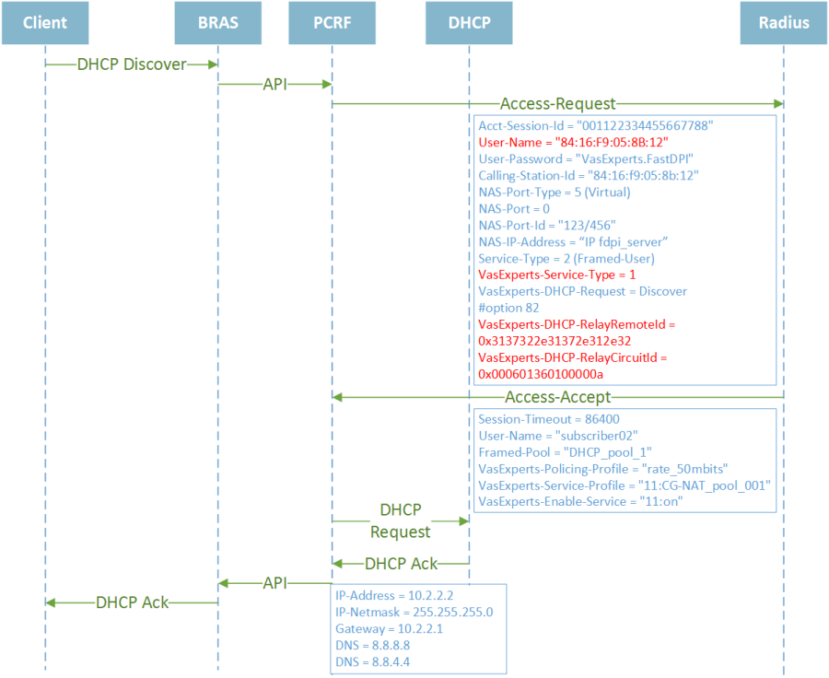
In brief, pool support can be described as follows:
SSG expects to receive the subscriber's IP address in the RADIUS Access-Accept response. The billing system behind RADIUS may, instead of issuing an IP address, provide the name of an address pool from which an address should be allocated to this subscriber. For IPv4, the pool name is specified in the Framed-Pool attribute; for IPv6, it is specified in the Framed-IPv6-Pool attribute.
FastPCRF, upon receiving the pool name in Access-Accept, requests the subscriber's IP address from the DHCP server. Upon receiving a response from the DHCP server, fastPCRF extracts the IP address from it, combines the options specified in the DHCP response with the Access-Accept attributes, and sends the authorization response to the subscriber via fastDPI.
General Parameters for IPv4 and IPv6 Pools:
Parameter | Description | Possible Values
dhcp_timeout | Timeout for waiting for a response from DHCP servers, in seconds | Default value: 3 seconds  Minimum value: 1 second  If dhcp_timeout=0, the default value is applied
The following sections describe technical details for configuring IP pool support in fastPCRF and operational specifics for each mode:
- IPv4 Pools - Framed-Pool Attribute and fastPCRF Configuration
- IPv6 Pools - Framed-IPv6-Pool Attribute and fastPCRF Configuration

