Raw fullflow compression

Introduction
SSG sends session information to IPFIX in chunks. In this case, information on each session can be divided into parts and stored in the database in the form of several lines of records. This creates an excessive storage load, especially in cases where long-term storage of the raw log is required.
The raw log compression function allows you to reduce the amount of raw log storage by gluing session parts into one record in the database. The function runs in a background process.

Configuration settings
Step 1. Go to Administrator → GUI Configuration → QoE Stor: Raw Log aggregation settings.
Set the values for all three parameters.
It is recommended to set the "QoE Stor aggregation time interval in hours" setting to more than 2 hours.
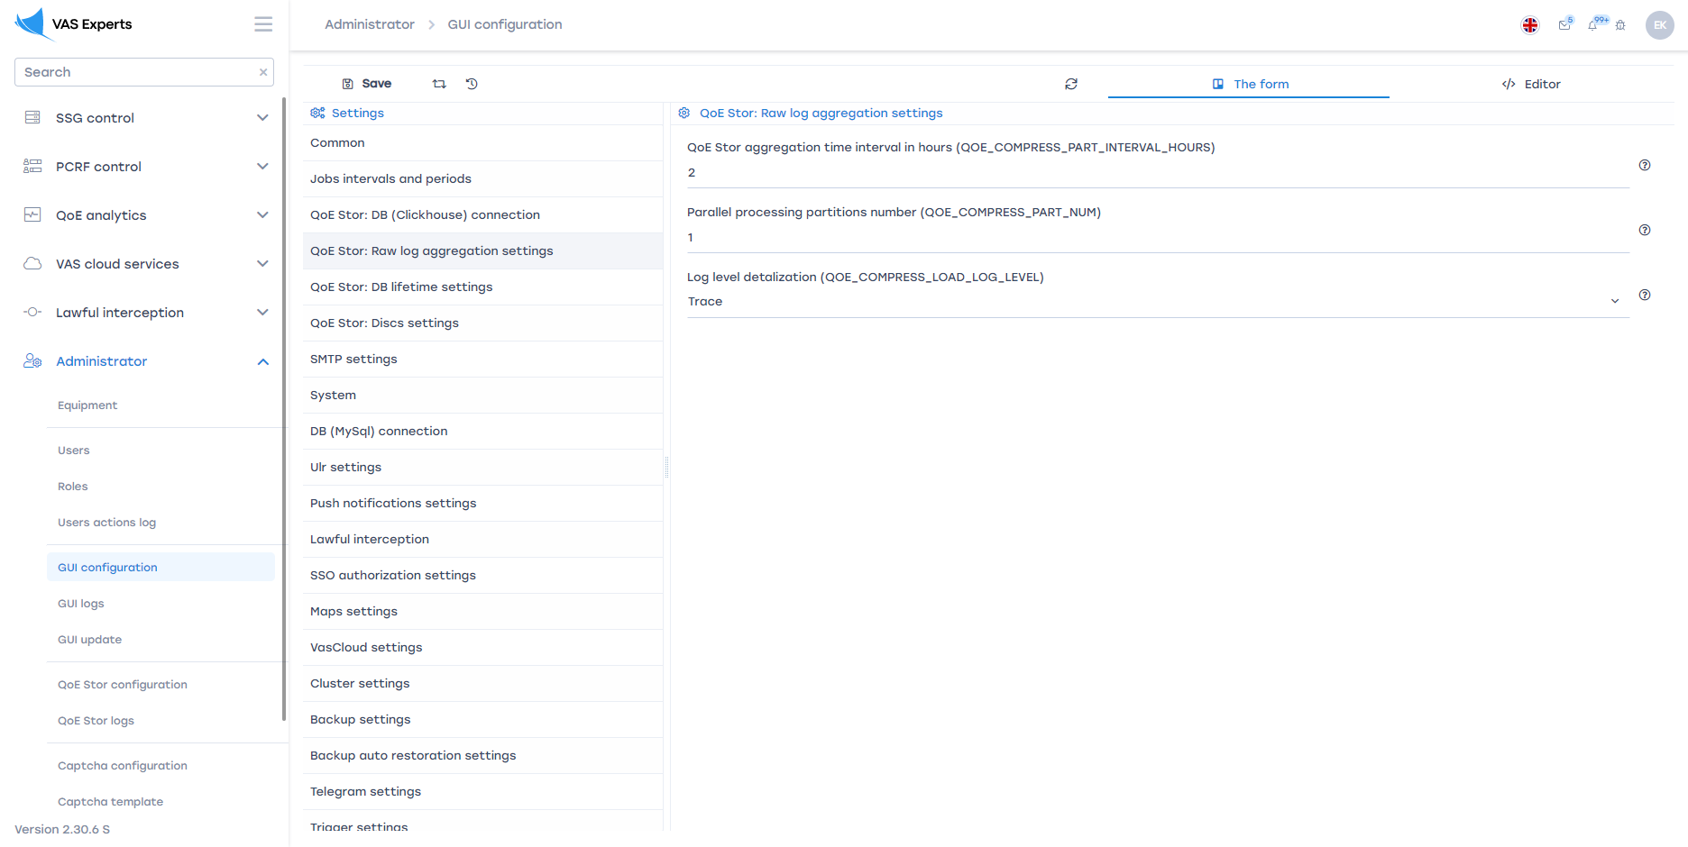
Step 2. Go to Administrator → Configuration QoE Stor → Fullflow log settings.
Set the "Enable FULLFLOW log background compressing" setting to "Enabled".
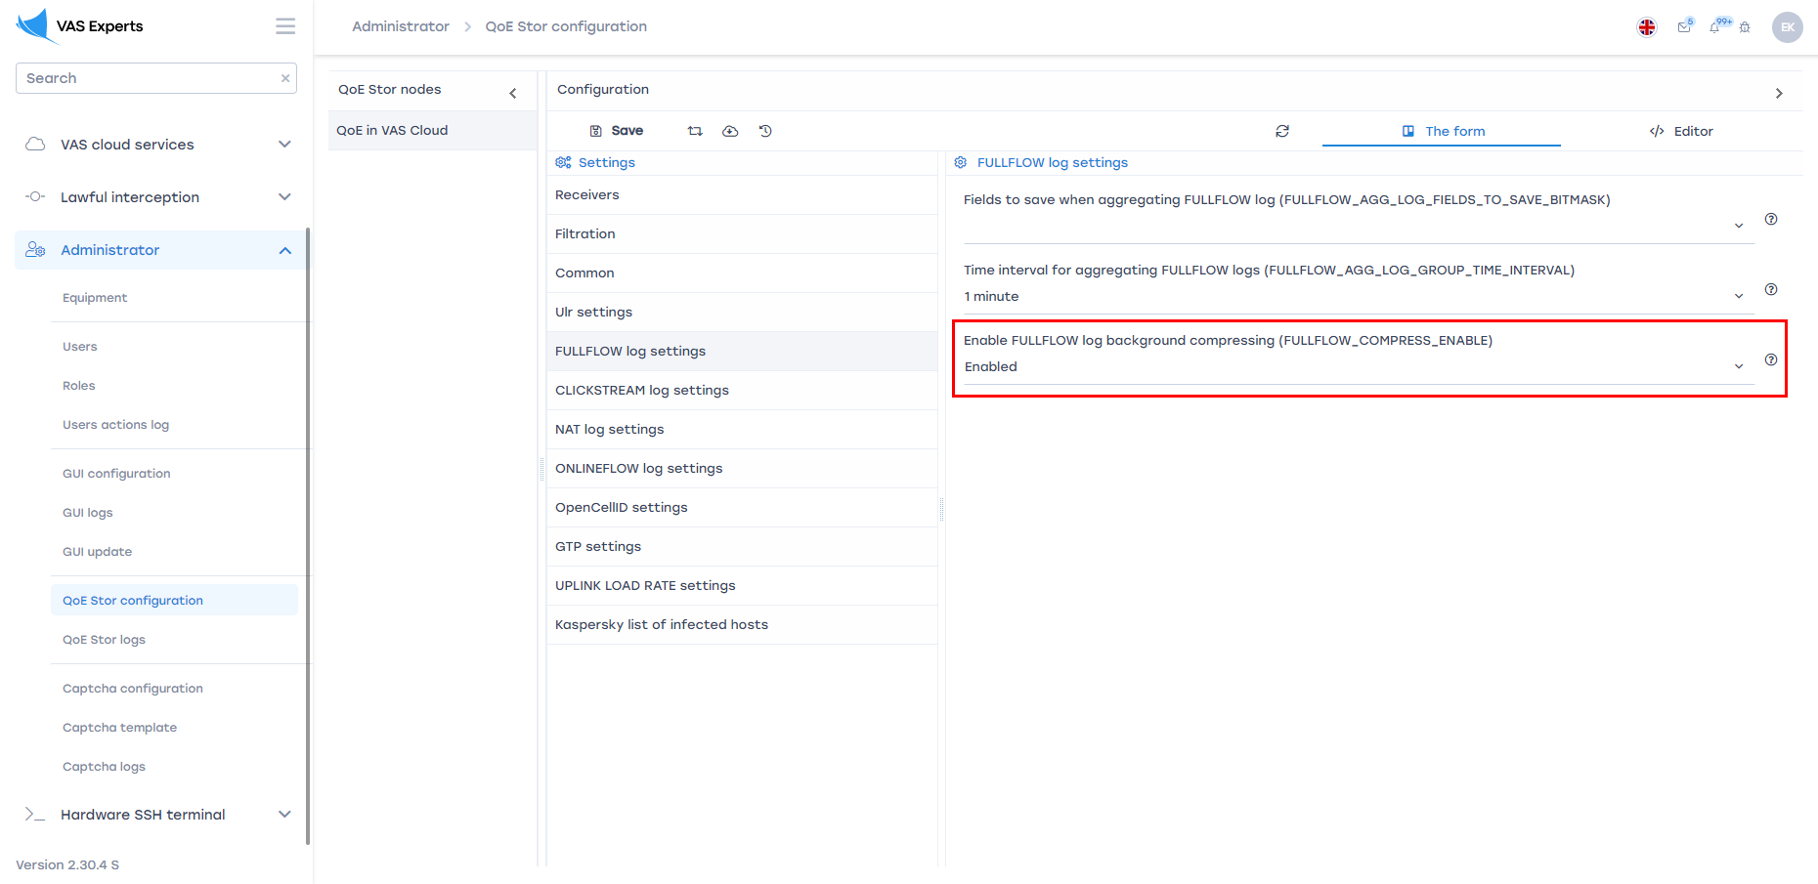

Fullflow Raw Log Compression Logs
Go to QoE analytics → Administrator → Tablesapce info → Aggregation raw logs fullflow info.
The opened section displays information about completed tasks for compression of raw fullflow log. It is possible to set the time period for which the data will be displayed and delete tasks.


