Connections
To go to the section, click the LAWFUL INTRCEPTION menu item, then click the CONNECTION menu item.
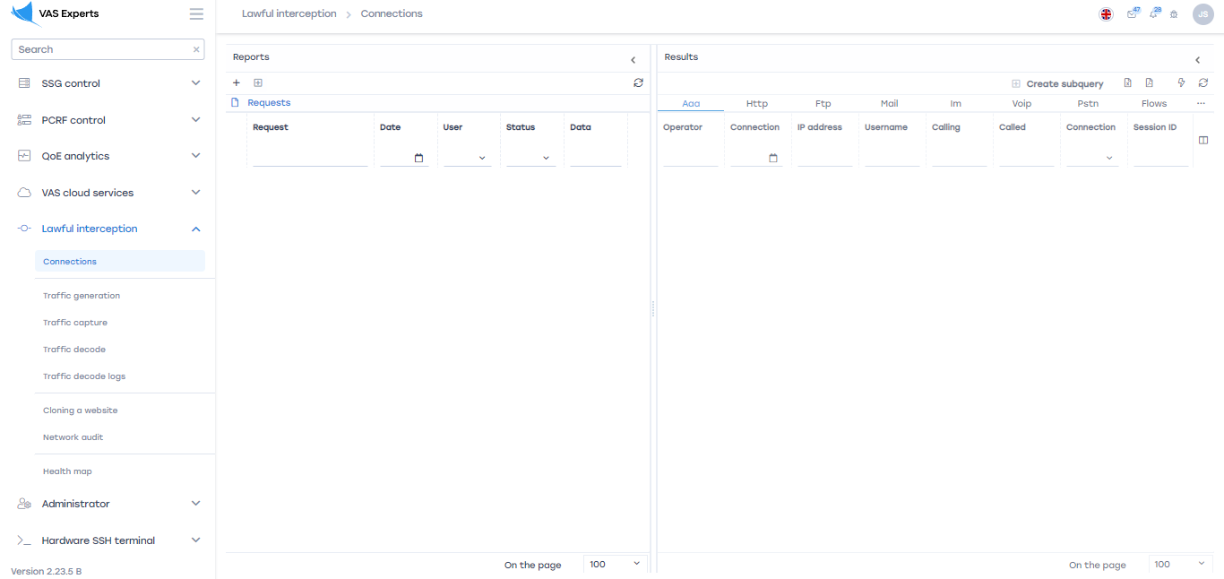

Reports

Add Request
To add a connection request, click on the "Add Request" button.
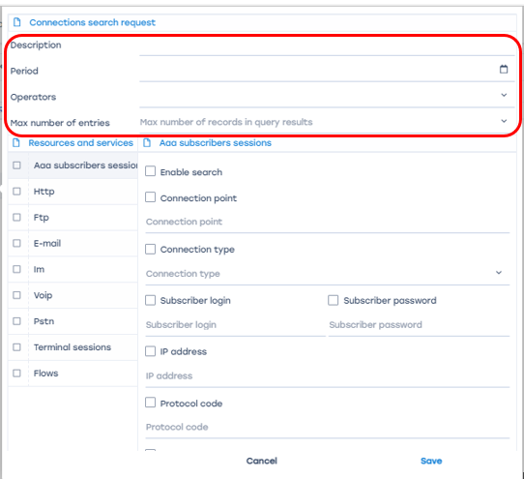
- Description. This field contains the name or description of the request.
- Period. This field is filled in by selecting the start and end dates of the period in the calendar.
- Operators. This field is filled in by selecting an operator from the drop-down list.
- Maximum number of entries. This field is filled in by selecting the number of entries from the drop-down list
- Resources and Services.

Aaa session subscribers
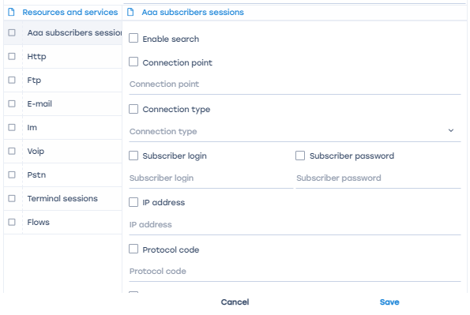
- Enable search. This option allows you to enable the search for subscribers.
- Connection point. ID of the data connection point.
- Connection type .
- Subscriber login. The subscriber's login is entered in this field.
- Subscriber's password. The subscriber's password is entered in this field.
- IP address. The subscriber's password is entered in this field.
- Protocol code. The protocol code is entered in this field.
- Phone card number UPD ping. The phone card number is entered in this field.
- Calling number. The calling number is entered in this field.
- Called number. The called number is entered in this field.
- Код зоны обслуживания (SAC). В данное поле вводится код зоны обслуживания.
- Mobile station ID. Enter the mobile station ID in this field.
- Access Point (APN). An access point is entered in this field.
- NAS server. Enter the IP address of the NAS server and the port of the NAS server in this field.
- GPRS/EDGE SGSN IP address. Enter the GPRS/EDGE SGSN IP address in this field.
- GPRS/EDGE GSM IP address. The GPRS/EDGE GGSN IP address is entered in this field.
- IMEI of the mobile subscriber. The IMEI of the mobile subscriber is entered in this field.
- Mobile subscriber's IMSI. The IMSI of the mobile subscriber is entered in this field.
- Modem pool number. The number of the modem pool is entered in this field.
- User equipment. Enter the MAC address, ATM Network Virtual Path Number (VPI) and ATM Network Virtual Channel Number (VCI) in this field.
- Base station (connection established). In this field, enter the base station area code (connection established), the base station code (connection established) and the base station time compensation (connection established).
- Base station (connection completed). In this field, enter the base station area code (connection completed), the base station code (connection completed) and the base station time compensation (connection completed).

Http
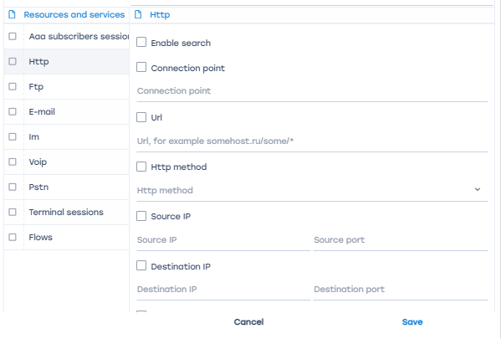
- Enable search. This option allows you to enable the search for subscribers.
- Connection point. ID of the data connection point.
- Url. Enter the url in this field.
- Http method. The http method is selected from the drop-down list.
- Source IP. In this field, enter the source Ip and the source port.
- Recipient's IP. In this field, enter the recipient's Ip and the recipient's port.
- Reason for termination. The reason for connection termination is entered in this field.
- Subscriber ID. The subscriber ID is entered in this field.

FTP
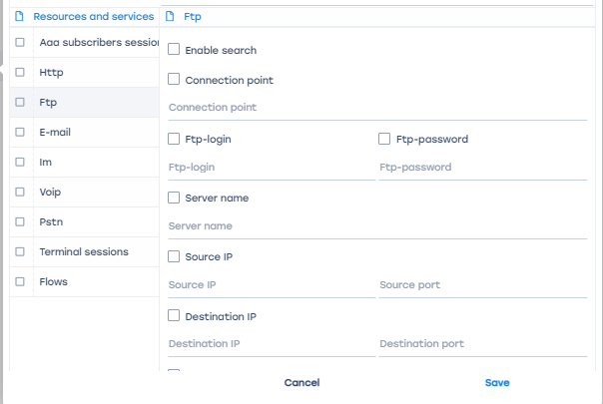
- Enable search. This option allows you to enable the search for subscribers.
- Connection point. ID of the data connection point.
- Sender. The sender's e-mail address is entered in this field.
- Recipient. The recipient's e-mail address is entered in this field.
- * Copy. In this field, enter the e-mail of the recipient of the copy of the mail message.
- Subject. The subject of the message is entered in this field.
- Message. The text of the message is entered in this field.
- Server name. In this field, enter the name of the server through which the email was sent.
- Attachments. You must select the option of having attachments from the drop-down list.
- Source IP. In this field, enter the source IP and the source port.
- Recipient IP. The recipient's IP address and the recipient's port are entered in this field.
- Reason for completion. The reason for connection termination is entered in this field.
- Subscriber ID. The subscriber ID is entered in this field.

E-mail
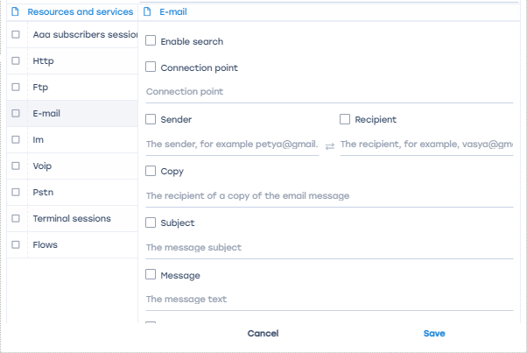
- Enable search. This option allows you to enable the search for subscribers.
- Connection point. ID of the data connection point.
- Sender. The sender's e-mail address is entered in this field.
- Recipient. The recipient's e-mail address is entered in this field.\
- Copy. In this field, enter the e-mail of the recipient of the copy of the mail message.
- Subject. The subject of the message is entered in this field.
- Message. The text of the message is entered in this field.
- Server name. In this field, enter the name of the server through which the email was sent.
- Attachments. You must select th

lm
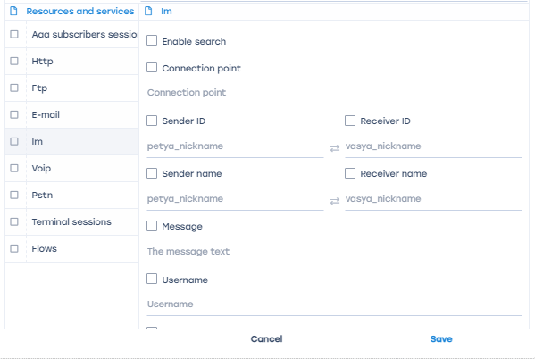
- Enable search. This option allows you to enable the search for subscribers.
- Connection point. ID of the data connection point.
- Sender ID. In this field, the user ID of the sender.
- Recipient ID. In this field, the user ID of the recipient.
- Sender's name. The sender's public name is entered in this field.
- Recipient's name. The recipient's public name is entered in this field.
- Message. The text of the message is entered in this field.
- User name. The user's password is entered in this field.
- Protocol. This field is filled in by selecting the protocol from the drop-down list.
- IP source.

Voip
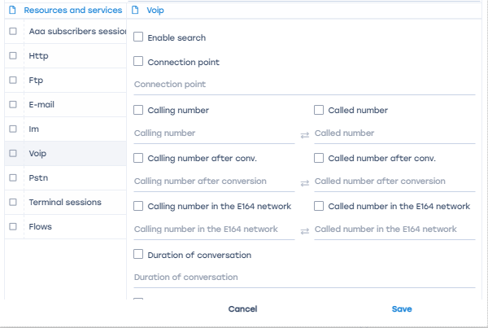
- Enable search. This option allows you to enable the search for subscribers.
- Connection point. ID of the data connection point.
- Calling number. The calling number is entered in this field.
- The called number. The called number is entered in this field.
- The calling number after conversion. The calling number is entered in this field after conversion.
- The called number after conversion. The number to be called after conversion is entered in this field.
- The calling number in the E164 network. The calling number in the E164 network is entered in this field.
- The called number in the E164 network. In this field, enter the called number in the E164 network.
- Duration of the conversation. The duration of the conversation in seconds is entered in this field.
- Connection method. The connection method is entered in this field.
- Initiator's name. Enter the name of the initiator of the communication in this field.
- Conference ID. The conference ID is entered in this field.
- Incoming beam for GSM Network. The incoming beam identifier for the GSM network is entered in this field.
- Incoming beam for W/CDMA, UMTS network. Enter the MAC address, ATM Network Virtual Path Number (VPI), and ATM Network Virtual Channel number (VCI) in this field.
- Outgoing beam for GSM Network. The outgoing beam identifier for the GSM network is entered in this field.
- Outgoing beam for W/CDMA, UMTS network. Enter the MAC address, ATM Network Virtual Path Number (VPI), and ATM Network Virtual Channel number (VCI) in this field.
- Protocol. This field is filled in by selecting the protocol from the drop-down list.
- I P-source. In this field, enter the source IP and the source port.
- Recipient IP. The recipient's IP address and the recipient's port are entered in this field.
- Reason for completion. The reason for connection termination is entered in this field.
- Subscriber ID. The subscriber ID is entered in this field.

Pstn
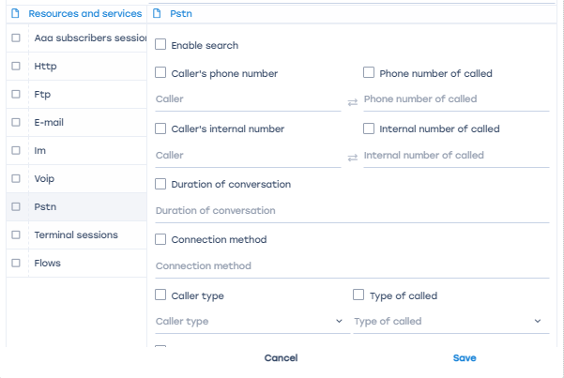
- Enable search. This option allows you to enable the search for subscribers.
- Caller's phone number. The caller's phone number is entered in this field.
- The phone number of the called. The phone number of the called person is entered in this field.
- Caller's internal number. The caller's internal number is entered in this field.
- Internal number of the called. The internal number of the called person is entered in this field.
- Duration of the conversation. The duration of the conversation in seconds is entered in this field.
- Connection method. The connection method is entered in this field.
- Caller type. This field is filled in by selecting the type from the drop-down list.
- Type of the called subscriber. This field is filled in by selecting the type from the drop-down list.
- Switch code. The switch code is entered in this field.
- Border switch code. The code of the border switch is entered in this field.
- DVO at connection. The DVO is entered in this field when connecting.
- Forwarding number. The forwarding number is entered in this field.
- Phone card number. The phone card number is entered in this field.
- Incoming beam. The ID of the incoming beam is entered in this field.
- Outgoing beam. The ID of the outgoing bundle is entered in this field.
- Reason for completion. The reason for connection termination is entered in this field.

Terminal sessions
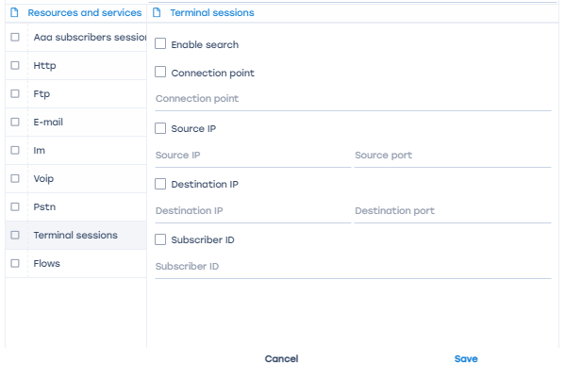
- Enable search. This option allows you to enable the search for subscribers.
- Connection point. ID of the data connection point.
- Source IP. In this field, enter the source IP and the source port.
- Recipient IP. The recipient's IP address and the recipient's port are entered in this field.
- Subscriber ID. The subscriber ID is entered in this field.

Flows
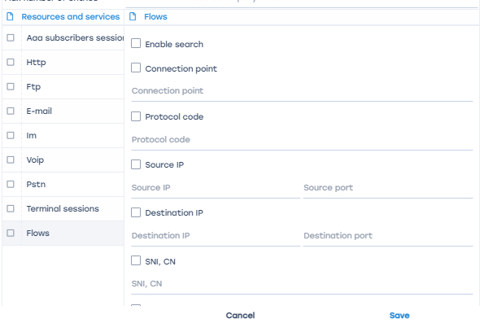
- Enable search. This option allows you to enable the search for subscribers.
- Connection point. ID of the data connection point.
- Protocol code. In this field, enter the protocol code in accordance with RFC1700, or the port number for TCP/UDP.
- IP source. In this field, enter the source IP and the source port.
- Recipient IP. The recipient's IP address and the recipient's port are entered in this field.
- SNI, CN. Enter SNI, CN.
- Subscriber ID in this field. The subscriber ID is entered in this field.

Add a subquery
To add a subquery to the connection, the user must click on the "Add subquery" button.
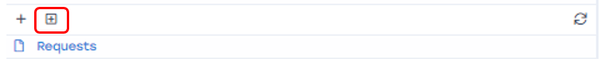
In the window that opens, set the parameters. The data entry procedure is described above.

Update
To update the list of requests, click on the "Update" button.
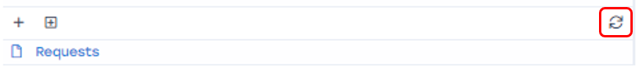

Change
To change the request parameters, click on the "Edit" button, which is located to the left of each list request.
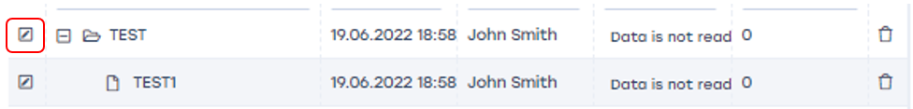

Delete
To delete a request, click on the "Delete" button, which is located to the right of each list request.


