Health map
To go to the Health map section, open the LAWFUL INTERCEPTION menu and HEALTH MAP.
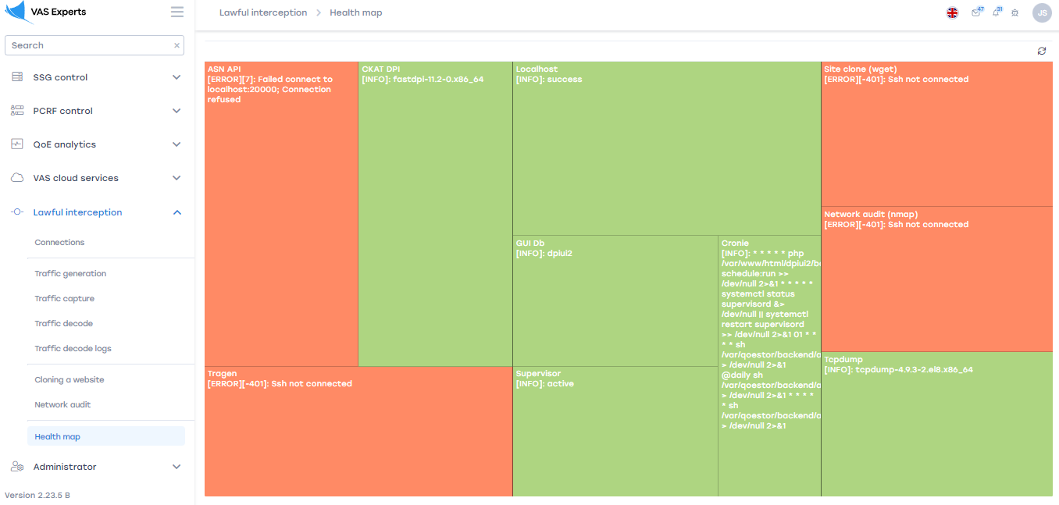
This section is designed to check the health of all services.

Description
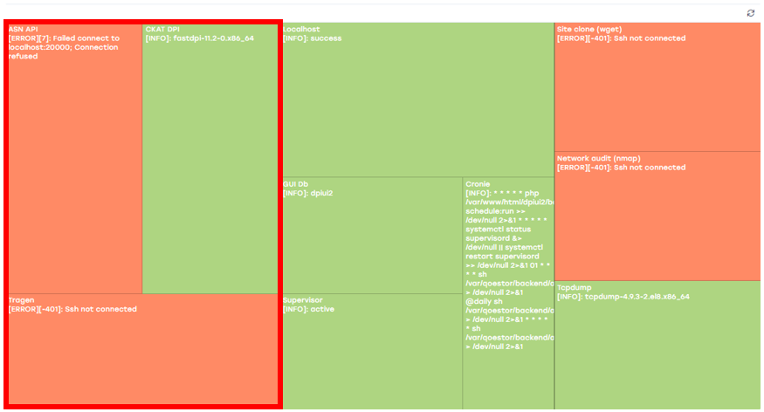
ASN API. Contains information about IP-addresses.
CKAT DPI. Information about traffic monitoring and analysis.
Tragen.
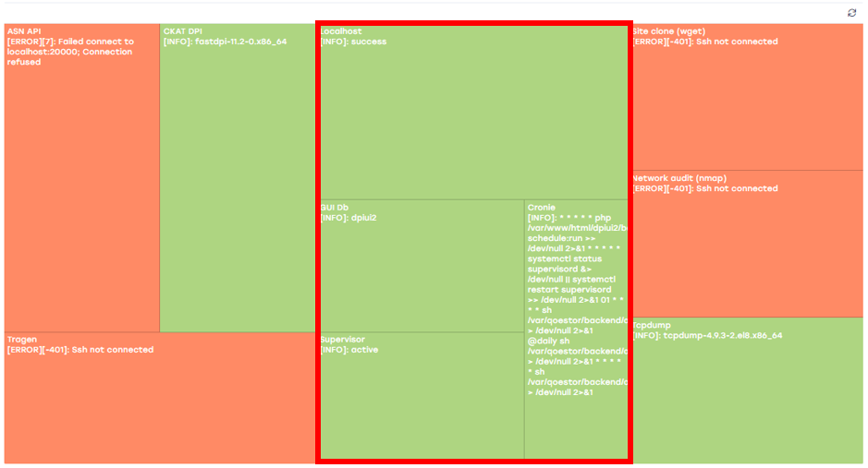
Localhost. Information about the status of this host.
GUI Db. Information about the database interface.
Cronie. Information about tasks performed by the task scheduler.
Supervisor. Contains information about the system designed to manage services.
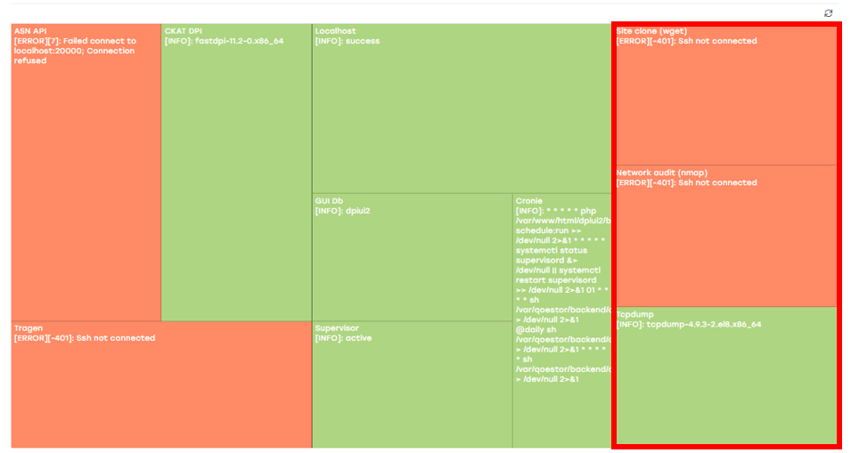
Site clone (wget). Information about the status of the "Website Cloning" section for this host.
Network audit (nmap). Information about the status of the "Network Audit" section for this host.
Tcpdump. General information about the status of the sections "Traffic generation", "Traffic capture", "Traffic analysis", "Traffic analysis logs" for this host.

