Information about dictionaries
In this section you can see a list of dictionaries and important information about them: dictionary file path, the number of records, date of creation, errors (if there are any).
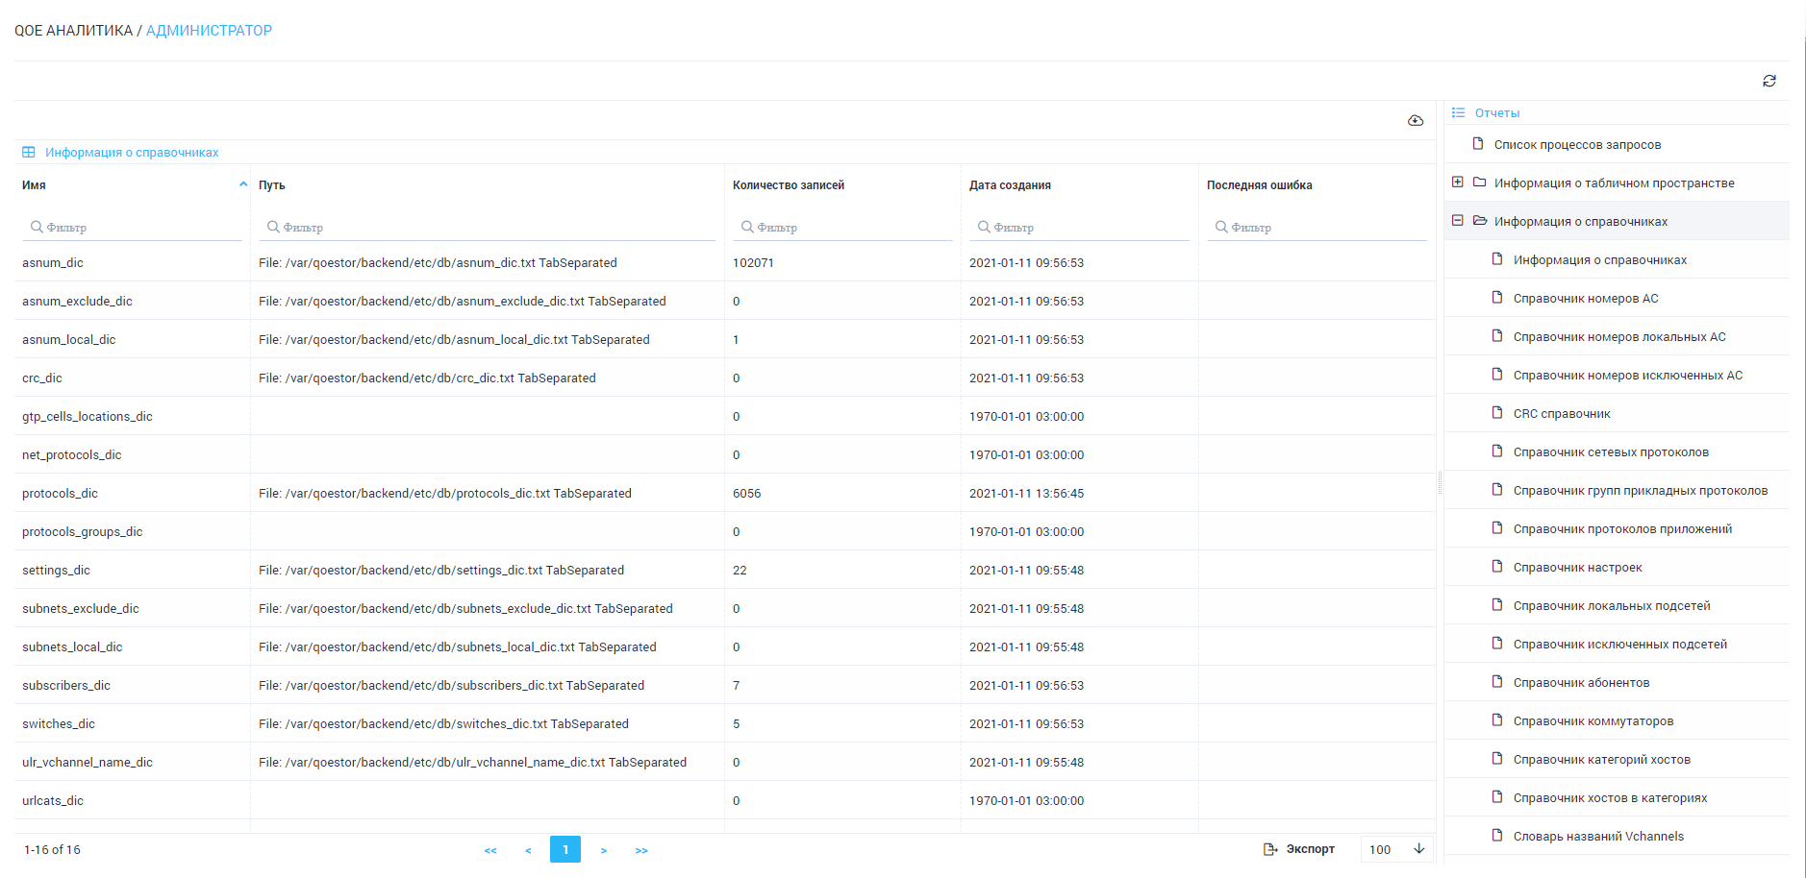
In the subsections you can see the contents of the dictionaries, such as the AS number directory.
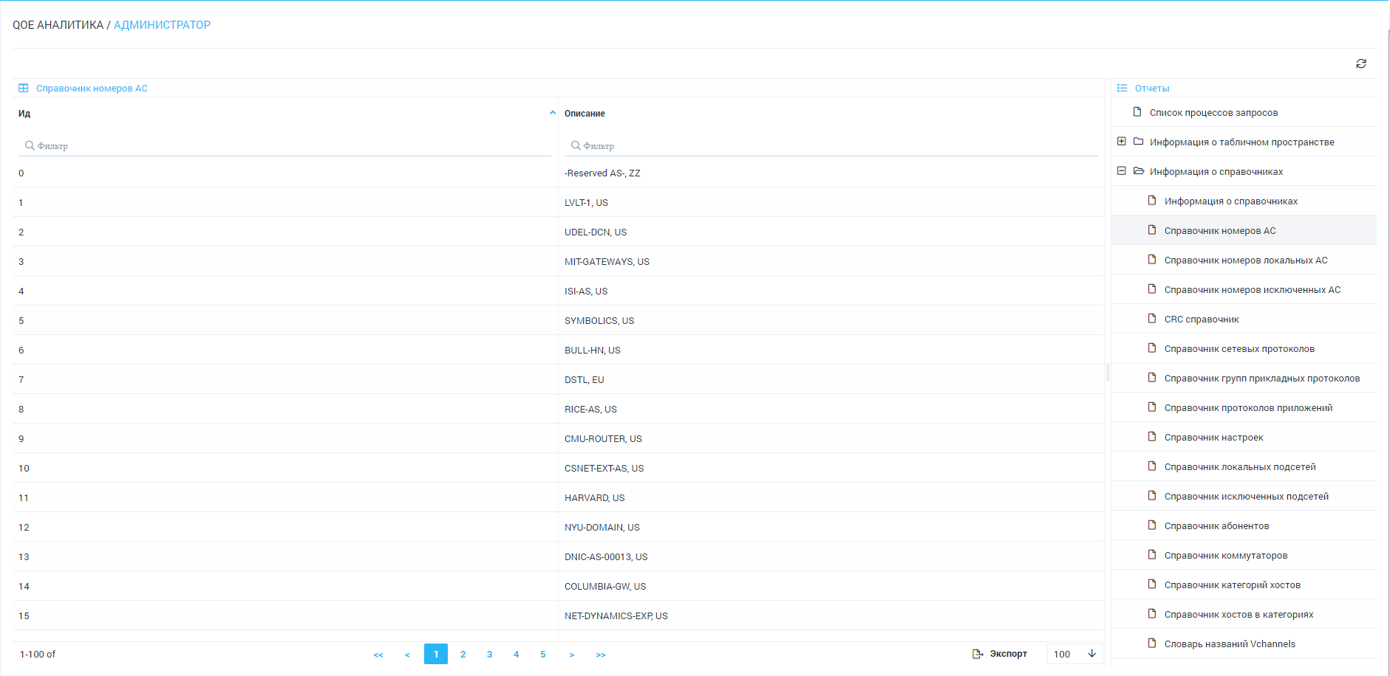
The system contains the following dictionaries:
- AS numbers directory
- Local AS numbers directory
- Excluded AS directory
- CRC directory
- Network protocols directory
- Application protocol groups directory
- Application protocols directory
- Configurations directory
- Directory of local subnets
- Directory of excluded subnets
- Subscribers directory
- Switches Directory
- Host Categories Directory
- Directory of hosts in categories
- Vchannels names dictionary
- Dictionary of GTP element locations

