Tablespace information

Tablespace information
In this section you can see how much disk space tables take up.
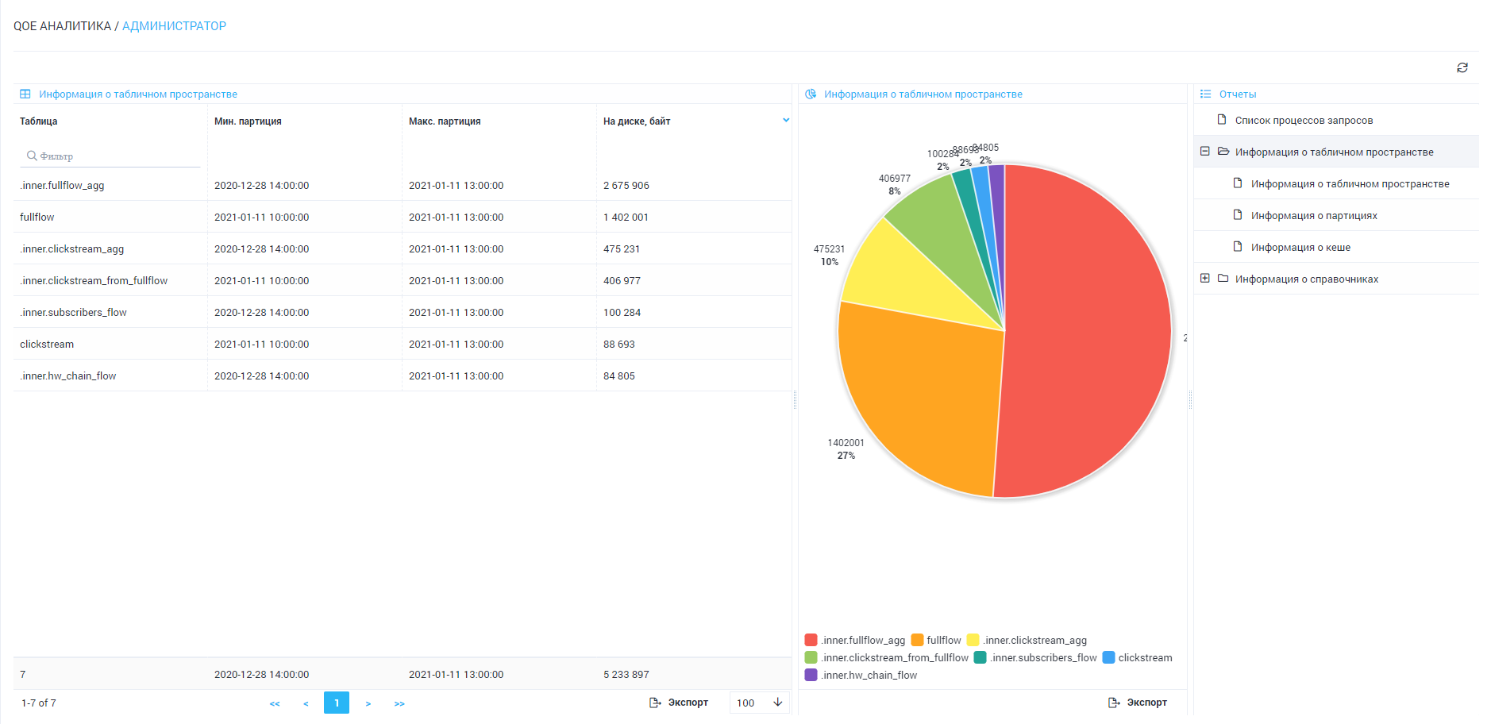

Partition information
In this section you can see a list of all table partitions, and how much disk space they take up.
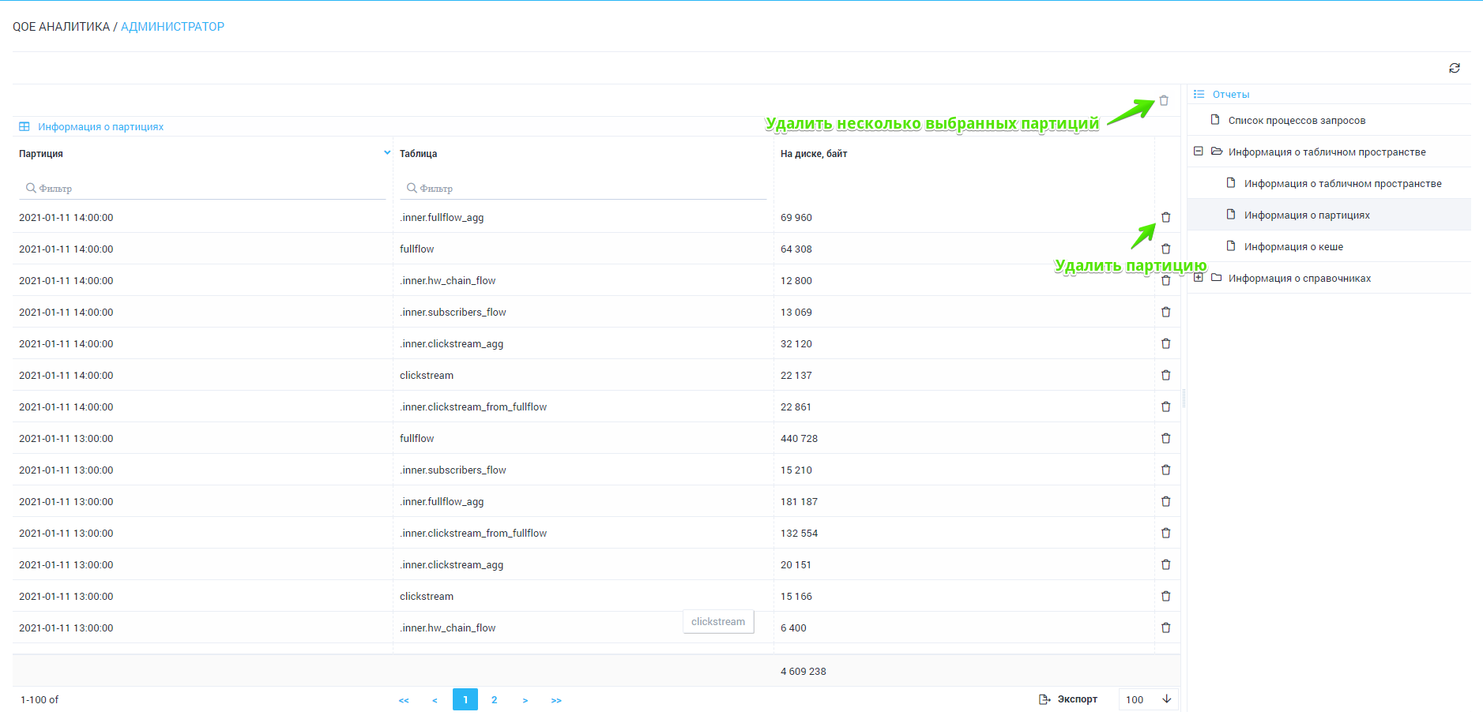
You can delete a partition. You can also delete multiple partitions by selecting them with Shift or Ctrl.

Cache information
In this section, you can see a list of constructed reports placed in the cache.
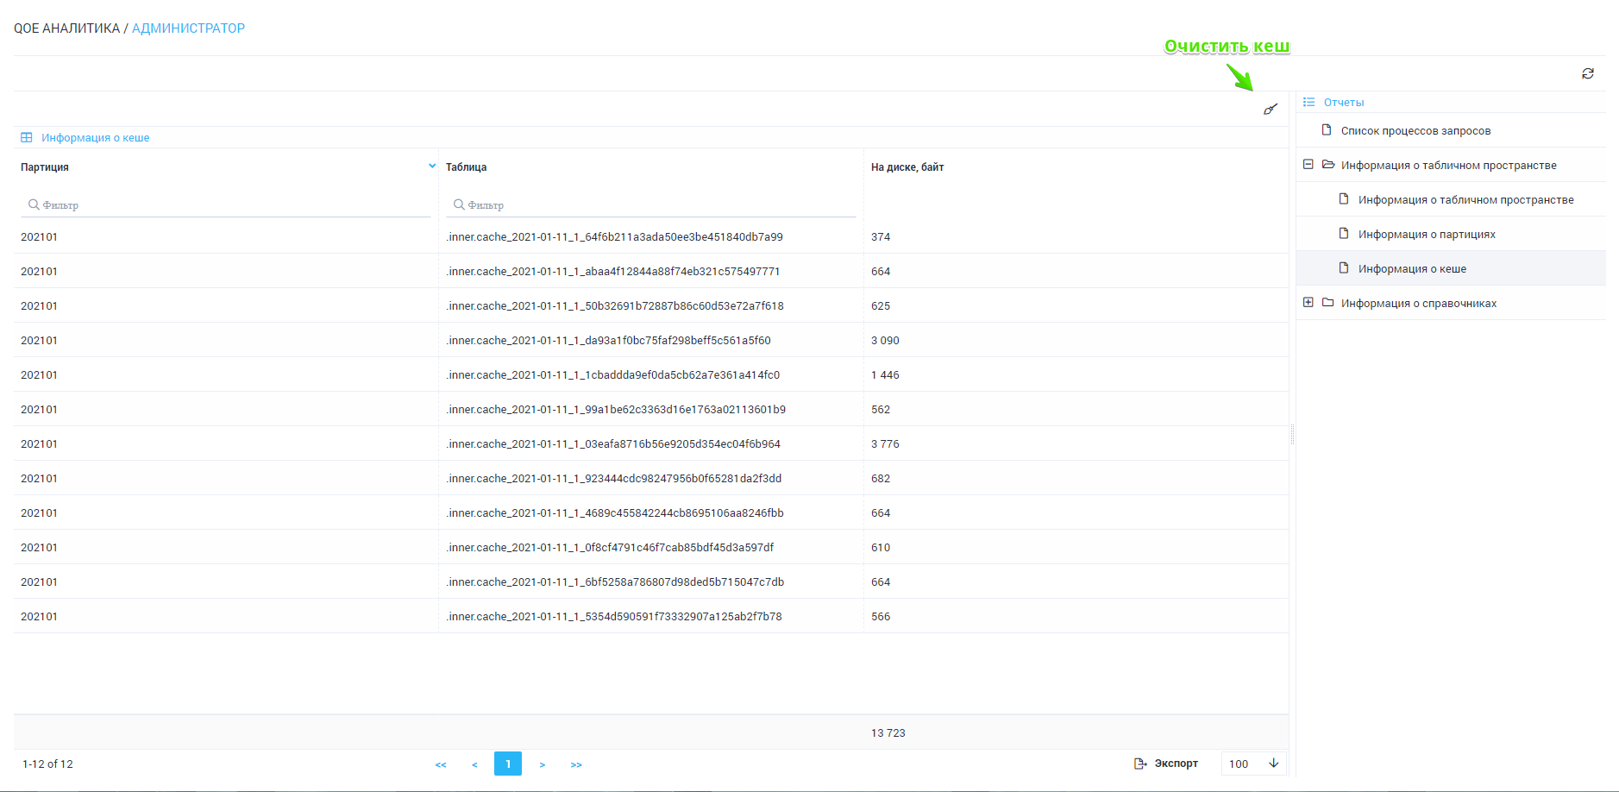
The cache can be cleared completely.

