QoE NAT Flow
NAT Log is exported from Stingray Service Gateway and accumulates in QoEStor database. These statistics are used to generate reports on user behavior in the event of a request from government agencies.
More about configuring NAT statistics collection in QoE stor

Viewing raw NAT log
Go to: Main Menu → QoE Analytics → NAT Flow → Raw NAT Flow
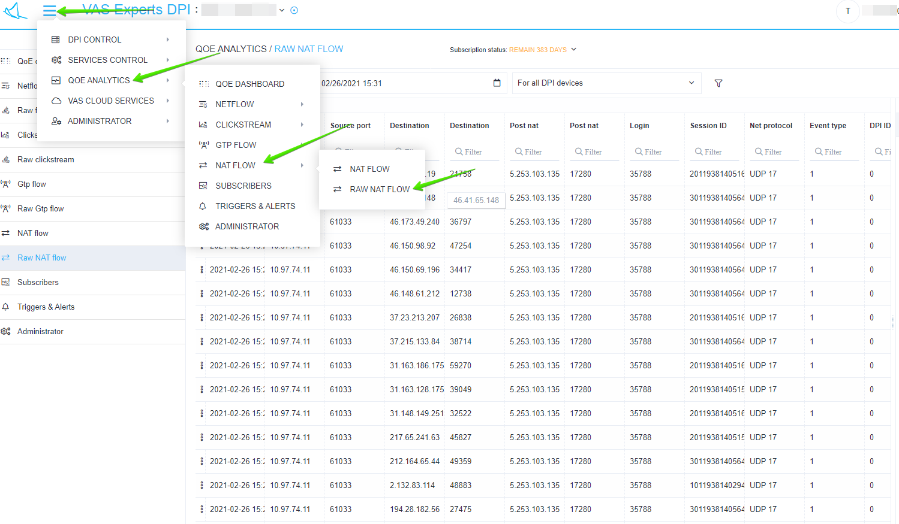
In the opened window you can select: period, DPI devices and manually set additional filters
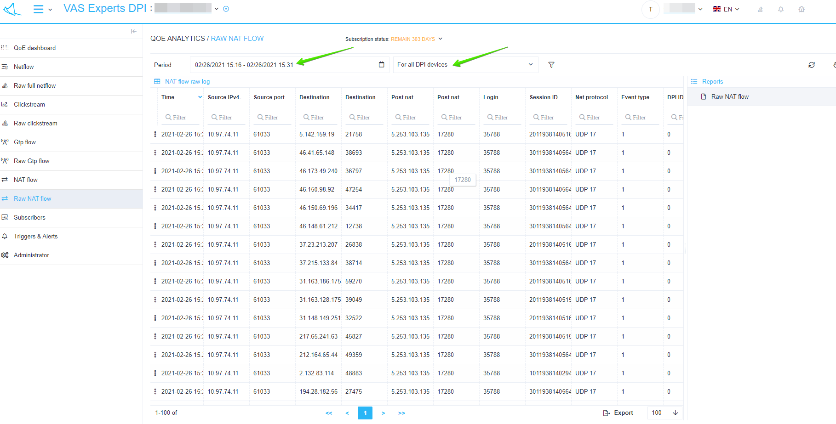

Viewing Aggregated NAT Log
Go to: Main menu → QoE analytics → NAT Flow → NAT Flow
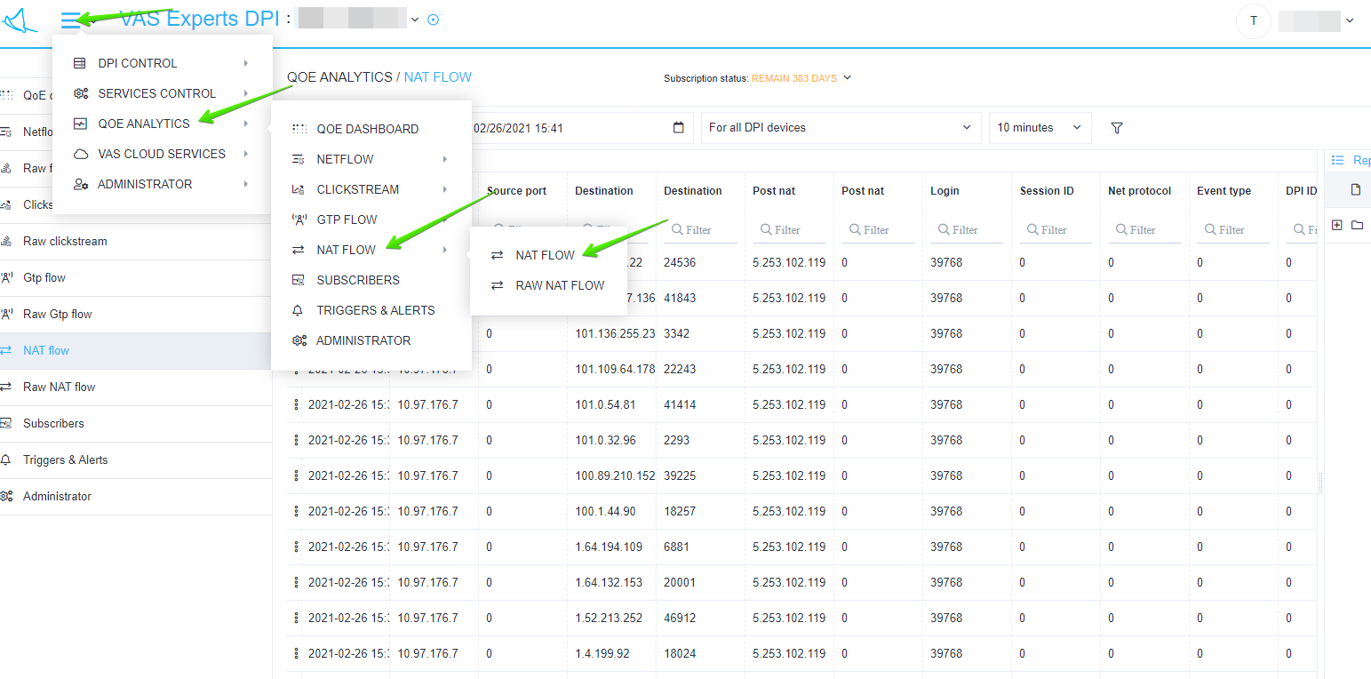
In the opened window you can select: period, DPI devices and manually set additional filters.
In the right sidebar, you can choose to generate reports by Tops: Top Subscribers, Top IP-addresses of hosts, Top IP-addresses NAT


