QoE NetFlow
This section contains reports for netflow analysis.
To switch to the section, open the QoE ANALYTICS menu and click NETFLOW
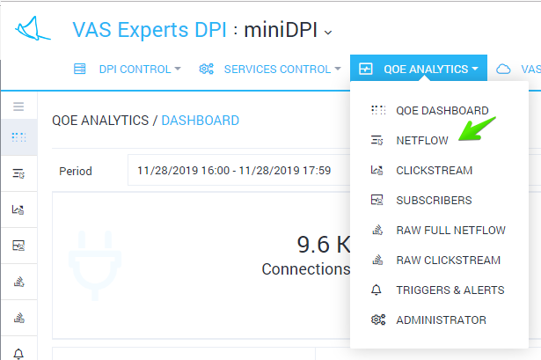
The section will be opened like the figure below.
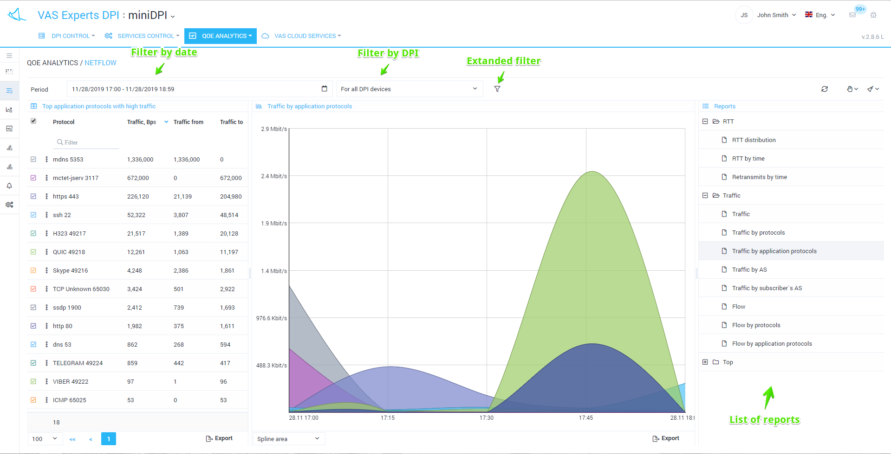
You can set filters for advanced analysis.


