QoE subscribers exporting to the advertising campaigns
In the “QoE Subscribers” section there is a feature allowing to create an advertising campaign and export a list of filtered subscribers.
Go to the QoE ANALYTICS/SUBSCRIBERS section. Select a filter. Click the “Add Subscribers to Camping” button.
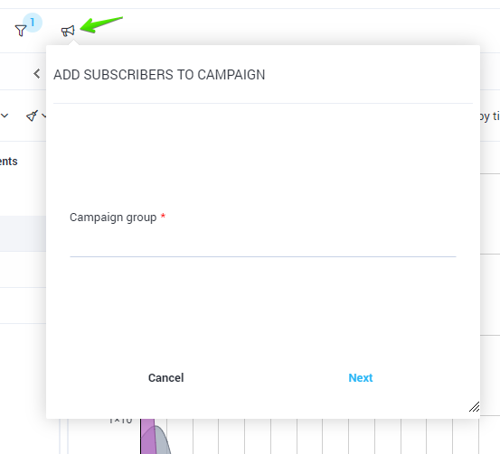
Enter the campaign profile (a new one will be created if there is no profile yet). At the next step, enter the campaign name (you will create a new one if there is no campaign yet).

At the next step, the campaign edit form will be opened. You can fill in or edit data.
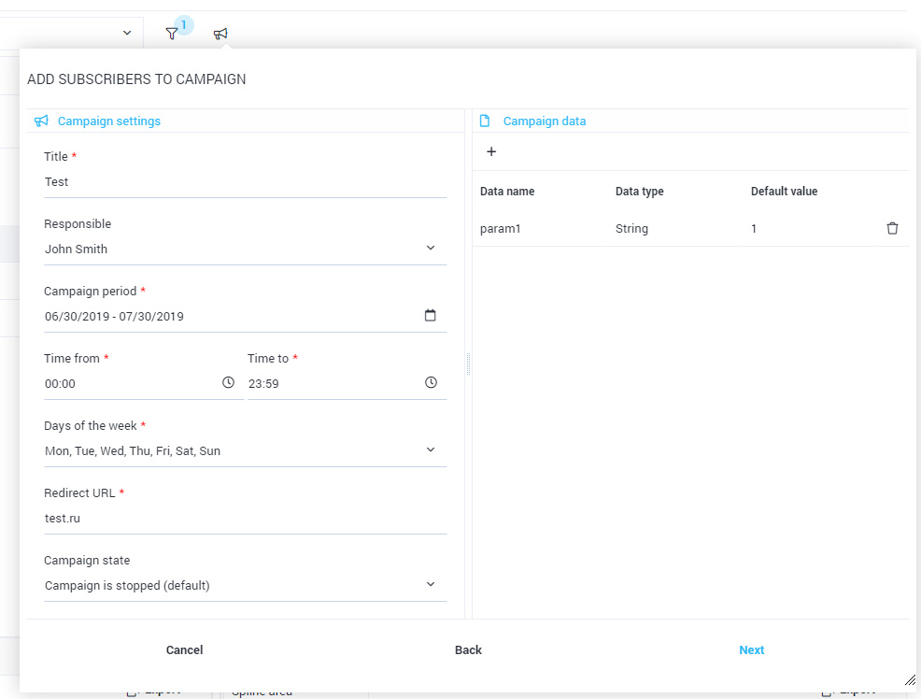
Finally, you need to choose a way to export subscribers: either by the IP address or login. If necessary, limit the number of subscribers.


