Site categories
Site categories - this section allows you to create the necessary categories for further sorting sites by them, as well as view the lists of existing sites in the selected categories.
To open the "Site Categories" section, open the main menu, hover over the "Classifier" item and click on the "Site Categories" item. (fig. 1)
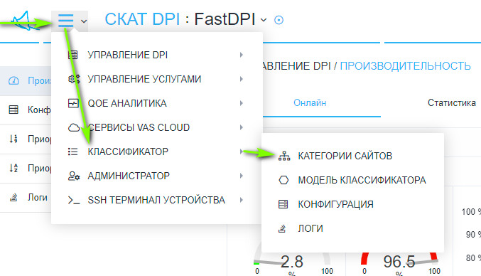
<html><center></html> (fig. 1) <html></center></html>
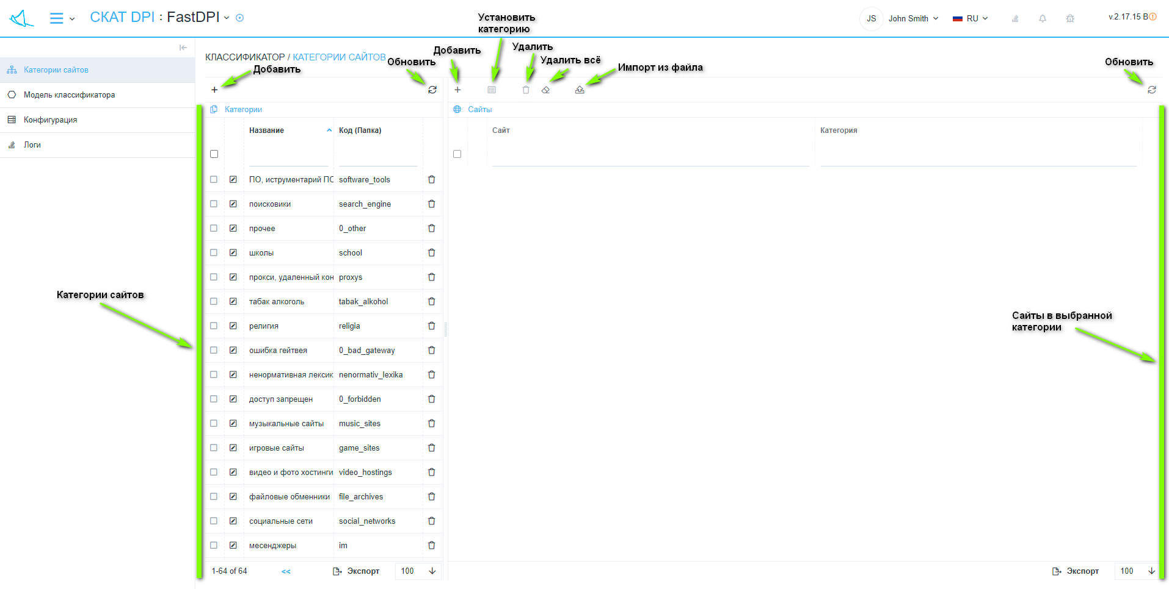
The section looks like the picture below. (fig. 2) <html><center></html> (fig. 2) <html></center></html>
"Site Categories" has sections:
- Categories (left):
  - Button "+" - opens a form (fig. 3) for adding a category.
  - "Refresh" button - refreshes the list of categories.
  - List of categories.
- Websites (right):
  - Button "+" - opens a form (fig. 4) for adding a site.
  - Button "Set category" - opens a form (fig. 8) for changing the category for several selected sites.
  - "Delete" button - deletes the selected sites.
  - "Delete All" button - deletes all sites in the selected categories.
  - Button "Import from file" - opens a form (fig. 7) for importing sites from a file into the selected category.
  - "Refresh" button - refreshes the list of sites in the selected categories.
  - List of sites in selected categories.
- The form for adding / editing a category (fig. 3) has:
  - The item "Title" (categories) - has a list for selecting a translation and a value input field for the corresponding translation, as well as a "+" button to add a translation version.
  - Item “Code” (folder) - assigns the name of the folder to the category on the server.
  - "Cancel" button - closes the form.
  - "Save" button - saves the form.
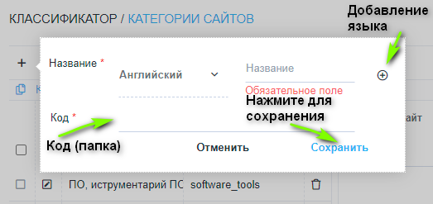
<html><center></html> (fig. 3) <html></center></html>
The form for adding / editing a site (fig. 4) has:
- Item "Site" - site address.
- Item "Category" - assigns the specified site to the selected category from the list.
- "Cancel" button - closes the form.
- "Save" button - saves the form.
- "Train" button - opens the machine learning form.
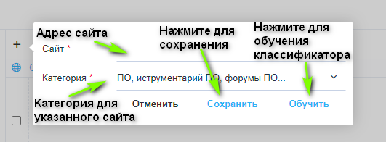
<html><center></html> (fig. 4) <html></center></html>
The machine learning form (fig. 5) has:
- Item "Site" - site address.
- "Get" button - get the text of the site (from point 1)
- Item "Site text" - the received text of the site
- Item "Category" - assigns the specified site to the selected category from the list.
- Item “Model” - assigns the selected model from the list to the specified site, adding and editing models is carried out in the section “Model of the classifier”.
- The button "Check" - performs a check and opens a form (Fig. 6), which displays: the correctness of recognition in percent and the probable category in the format "Category name (Code / Folder)" for the specified site (from point 1).
- "Cancel" button - closes the form.
- "Save" button - saves the form.
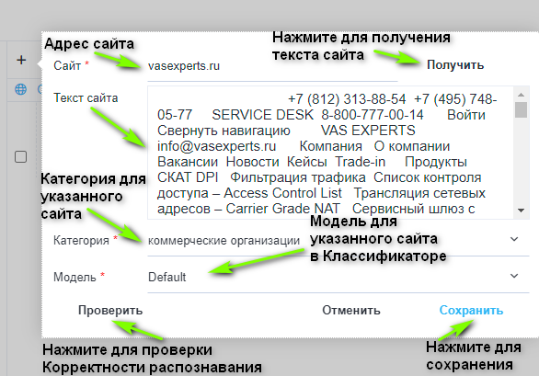
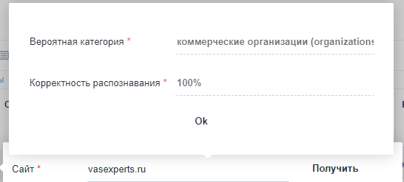
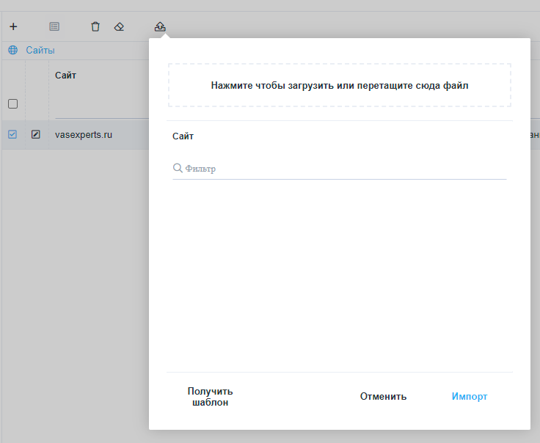
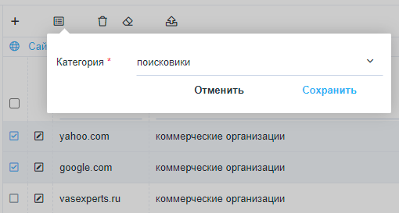
<html><center></html> (fig. 5) <html></center></html> <html><center></html> (fig. 6) <html></center></html> <html><center></html> (fig. 7) <html></center></html> <html><center></html> (fig. 8) <html></center></html>

