Classifier configuration
To open the "Classifier configuration" section, open the main menu, point to the "Classifier" item and click on the "Configuration" item. (fig. 1)

<html><center></html> (fig. 1) <html></center></html>
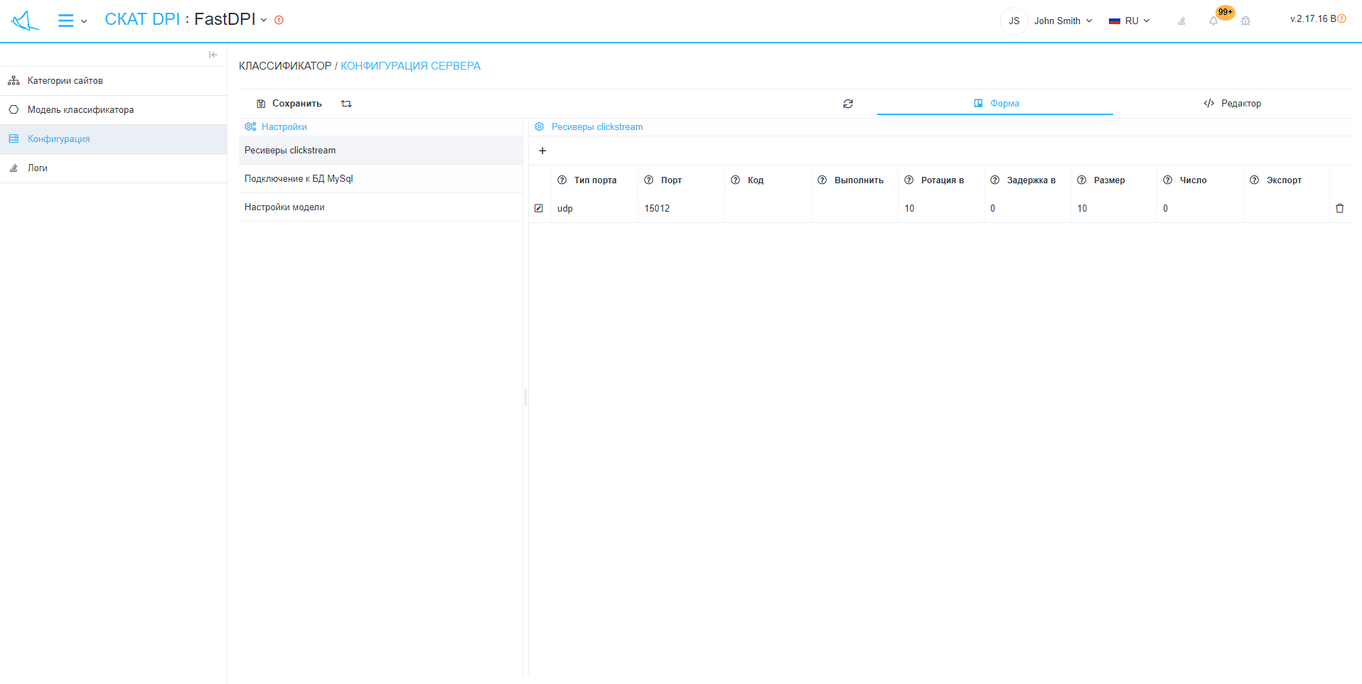
The section looks like the picture below. (fig. 2) <html><center></html> (fig. 2) <html></center></html>
"Classifier configuration" has sections:
- Settings:
  - Button "Save" - ​​saves changes in the configuration of the classifier.
  - "Restart" button - restarts the classifier with the updated configuration.
  - "Refresh" button - requests the last saved configuration from the server.
  - Switch "Form / Editor" - toggles the editing modes of the configurator
    - Form - allows you to edit the server configuration using the graphical interface.
    - Editor - allows you to edit the server configuration by editing the configuration file directly, that is, in text format.
- List of configuration categories:
  - Clickstream receivers
    - Button "+" - opens a form (fig. 3) for adding a receiver.
    - List of receivers.
- Connection to MySql DB
  - DB connection type (DB_CONNECTION)
  - Database host (DB_HOST)
  - DB port (DB_PORT)
  - Database name (DB_DATABASE)
  - Database username (DB_USERNAME)
  - DB password (DB_PASSWORD)
- Model settings
  - Default models (CFG_SITES_CLSFR_MODEL)
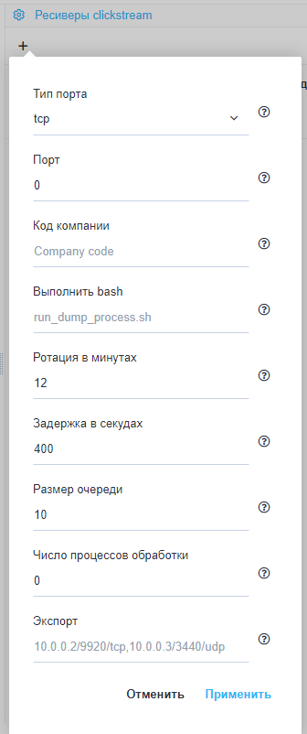
<html><center></html> (fig. 3) <html></center></html>

