Classifier logs

To open the "Classifier logs" section, open the main menu, point to the "Classifier" item and click on the "Logs" item. (fig. 1) <html><center></html> (fig. 1) <html></center></html>
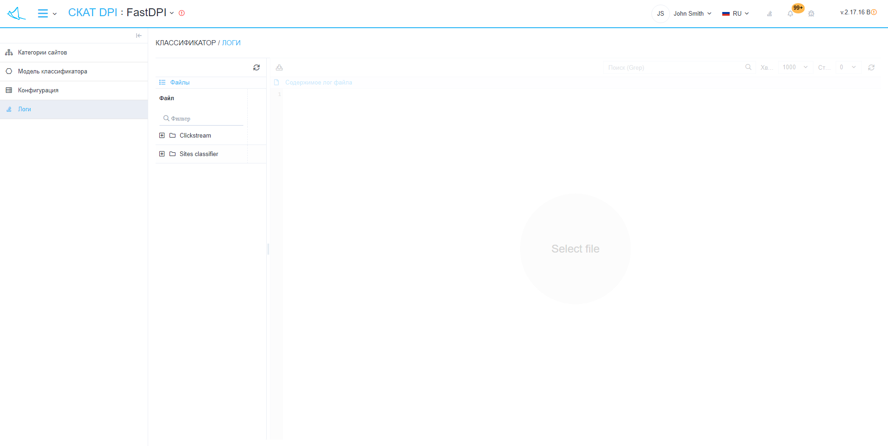
The section looks like the picture below. (fig. 2) <html><center></html> (fig. 2) <html></center></html>
"Classifier logs" has sections:
- Files:
  - "Refresh" button - refreshes the list of files.
  - List of files.
- Content of the log file:
  - Button "Download file completely" - downloads the file to your device.
  - Options
    - Search (Grep)
    - Tail
    - Number of lines before and after matching
- "Refresh" button - loads the contents of the file from the last saved copy.
- A form for viewing the contents of the selected file.

