Classifier model
Classifier model - this section allows you to use the convenience of the graphical interface to access files on the server, works like a file manager.
To open the "Classifier Model" section, open the main menu, point to the "Classifier" item and click on the "Classifier Model" item.

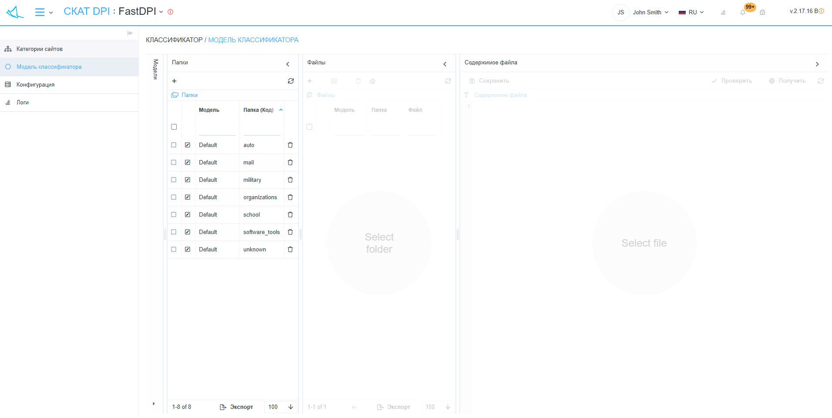
The section looks like the picture below.
The "Classifier Model" has sections:
- Models (hidden by default, click on the inscription "Models" to open):
  - Button "+" - opens a form (fig. 3) for adding a model.
  - Button "Duplicate model" - opens a form (fig. 4) for duplicating a model.
  - Button "Set model by default" - opens the form (fig. 5) for setting the model by default.
  - "Refresh" button - refreshes the list of models.
  - List of models.
- Folders (Code):
  - Button "+" - opens a form (fig. 6) for adding a folder (code).
  - "Refresh" button - refreshes the list of folders (code) in the selected models.
  - List of folders (code) in the selected models.
- Files:
  - Button "+" - opens a form (fig. 7) for adding a file.
  - Button "Set folder" - opens a form (fig. 8) for changing the model and folder for the selected files.
  - "Delete" button - deletes the selected sites.
  - "Delete All" button - deletes all sites in the selected categories.
  - "Refresh" button - refreshes the list of files in the selected folders.
  - List of files in selected folders.
- File contents:
  - "Save" button - saves changes in the selected file.
  - The "Check" button - performs a check and opens a form (fig. 9), which displays: the correctness of recognition in percent and the probable category in the "Category name (Code / Folder)" format for the content of the selected file.
  - Button "Get" - opens a form (Fig. 10) for receiving the text of the site by URL.
  - "Refresh" button - refreshes the content of the selected file.


