Performance
To go to the Performance section, open the "DPI CONTROL" menu and click on the "Performance".
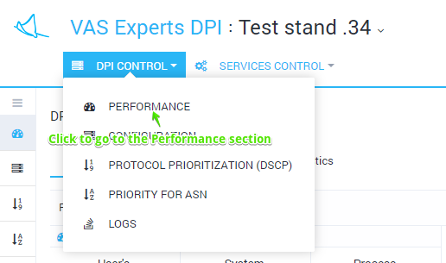
The section contains 2 subsections:
- Online - the current state in real time is displayed
- Statistics - the accumulated statistics for the period are displayed

Online
This section shows the current state of DPI performance in real time.
It is possible to switch between 2 tabs:
- Processors and memory - Processors and memory usage are displayed
- Top 30 processes - TOP 30 processes list is displayed

Processors and memory
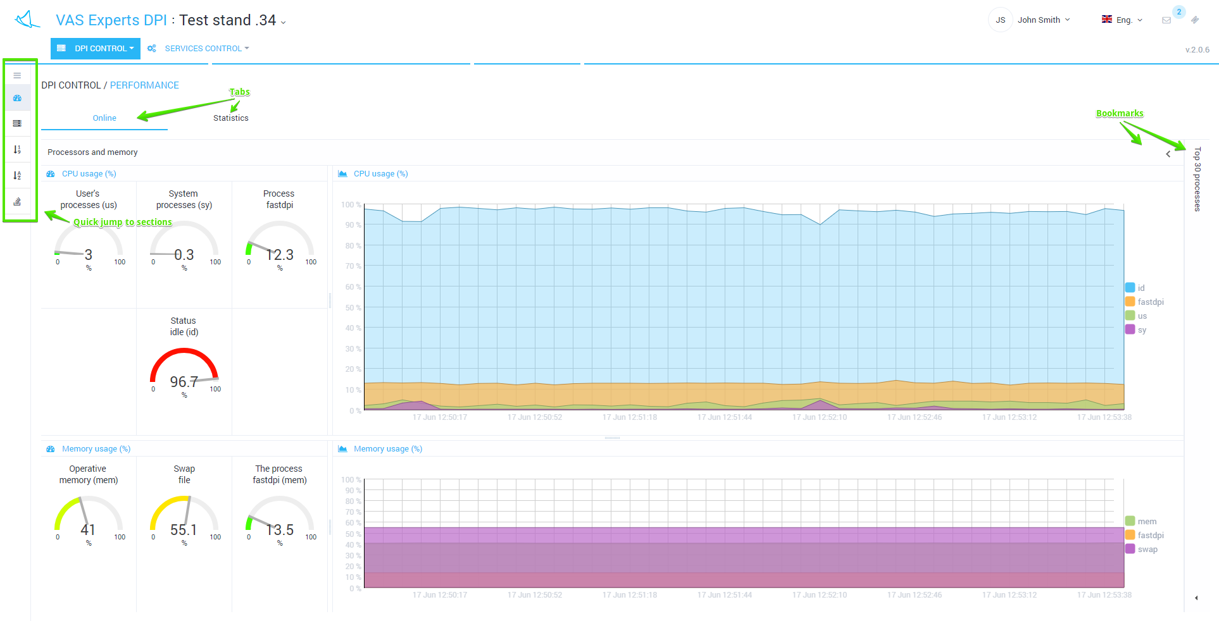

Top 30 processes
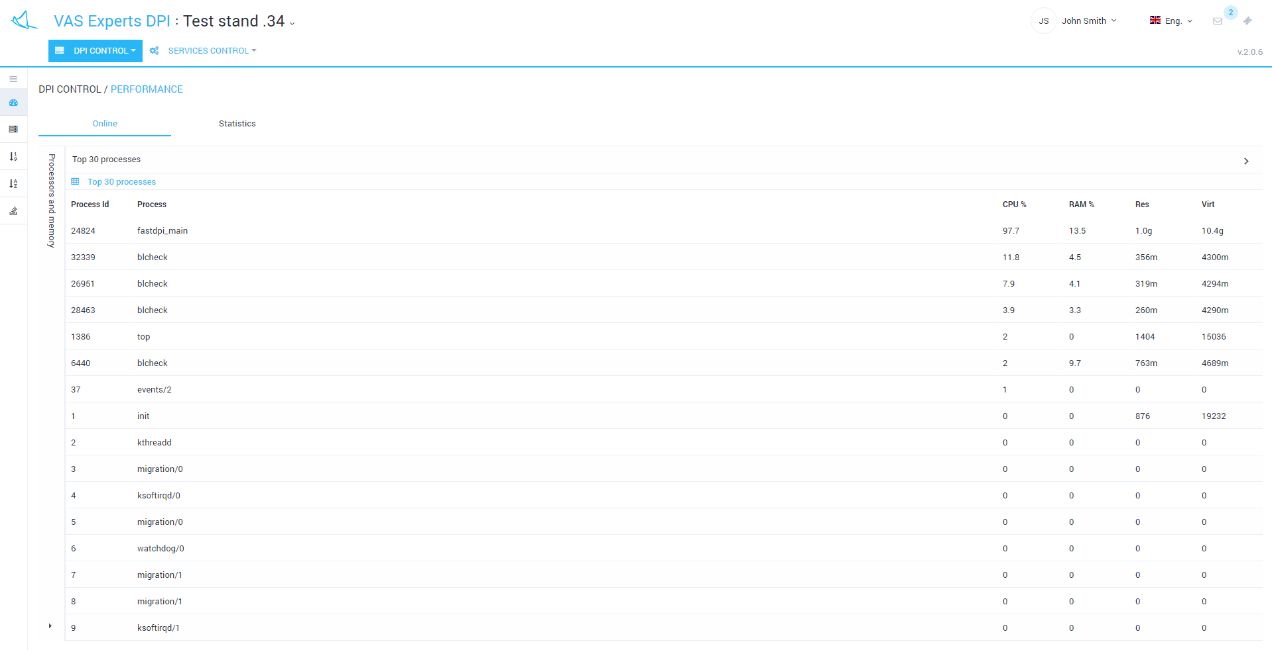

Statistics
This section shows the accumulated statistics for the period. You can change the period and the interval for displaying the data.
It is possible to switch between the following tabs:
- Processors and memory (statistics) - Processors load and memory usage statistics are displayed
- HTTP statistics - processed and blocked HTTP requests statistics are displayed
- Network interfaces dna0-dnaX - traffic statistics per dna interface

Processors and memory (statistics)
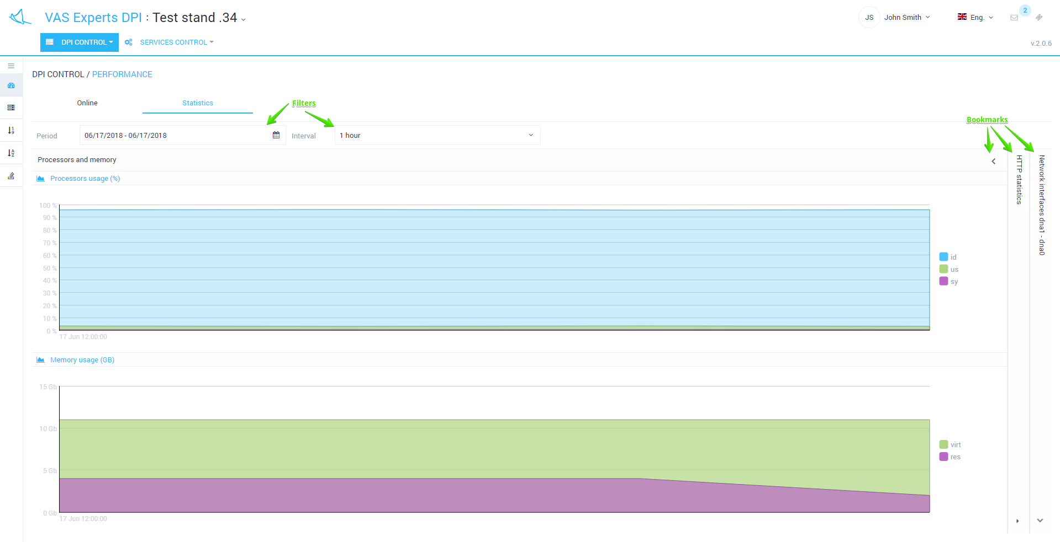

HTTP statistics
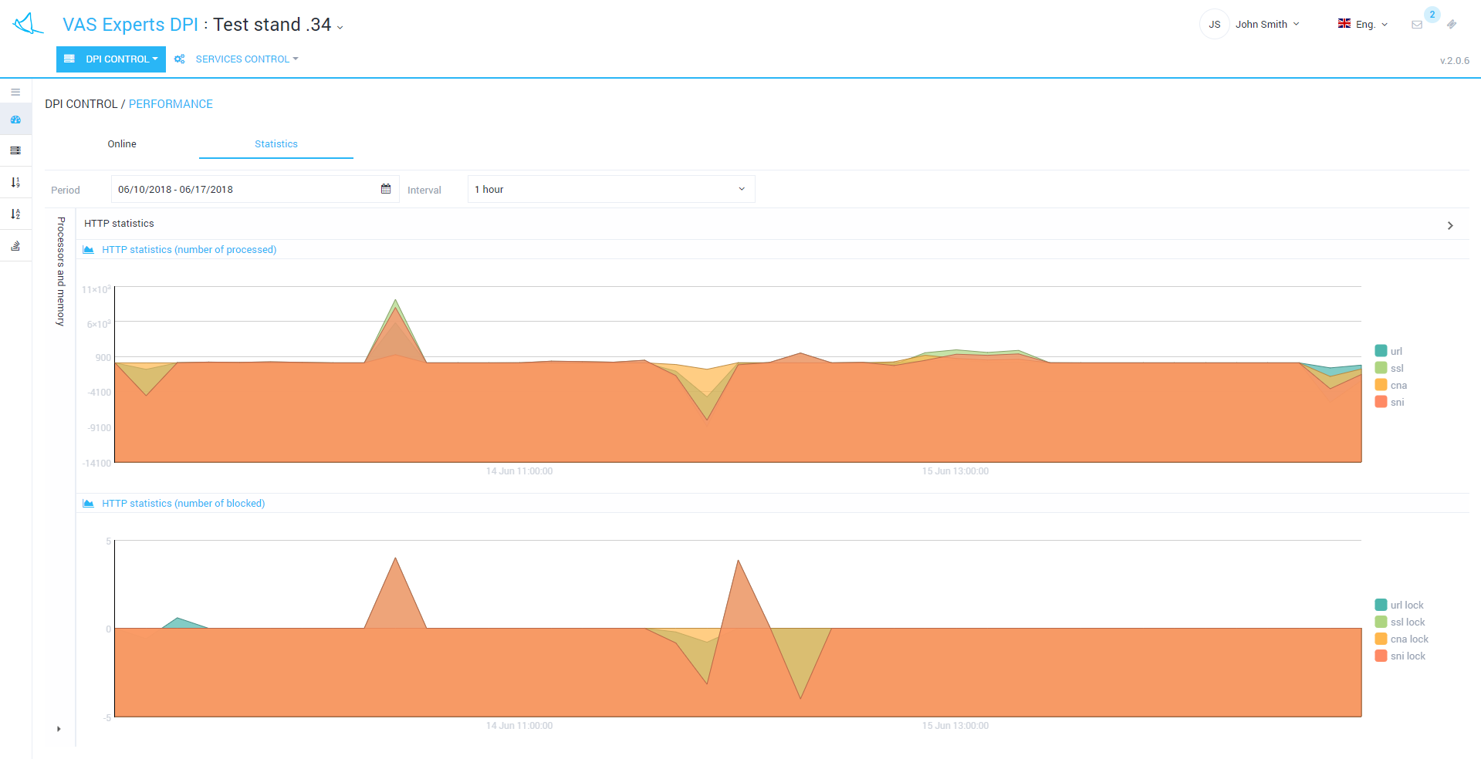

Network interfaces dna0-dnaX


