SNMP Monitoring via snmpd Service

Description
SNMP is a protocol that allows retrieving information about the SSG server for centralized monitoring of critical parameters. This is implemented using the snmpd service included in the operating system.
Operation principle: An SNMP query is sent to the server, the snmpd service collects the required information and sends it to the monitoring server. The monitoring server receives and processes this information, enabling status monitoring of the server - tracking parameter levels and data.
The bngsnmp package contains scripts required for building the VENDOR OID branch for SNMP polling.
It's based on the snmp_passpersist library. Vendor OID branch: .1.3.6.1.4.1.43823
Vendor branch components:
- CPU statistics, including core utilization by BNG processes;
- Number of illegitimate drops;
- Dispatcher drop statistics;
- RADIUS server availability list (when using a proxy or load balancer, the proxy will be shown in statistics);
- DHCP subscriber count - with active functionality;
- PPPoE, L2TP, PPP subscriber count - with active functionality;
- VRF list and active subscribers in each - with active functionality;
- DPDK interface statistics (packet count, errors, signal level etc.);
- NAT statistics (profile list, pool list, and translation count per public address) - with active functionality;
- Hardware module list installed on motherboard - if supported by BMC controller;
- Hardware sensor readings (voltage, power consumption, FAN RPMs) - if supported by BMC controller;
- DHCP pool utilization (supported only with KEA-DHCP server) - with active functionality.
This script also overrides standard branches by adding DPDK interface statistics:
- .1.3.6.1.2.1.2.2.1 - 32-bit counters
- .1.3.6.1.2.1.31.1.1.1 - 64-bit counters
If needed, override can be disabled by commenting or removing these lines from /etc/snmp/snmpd.conf:
pass_persist .1.3.6.1.2.1.2.2.1 /usr/local/bin/bng_snmp/vaspp
pass_persist .1.3.6.1.2.1.31.1.1.1 /usr/local/bin/bng_snmp/vaspphc
MIB file location after installation: /usr/share/snmp/mibs/VASEXPERTS-MIB.txt

Installation
- Installation (net-snmp, net-snmp-utils will be installed as dependencies):
yum install bngsnmp
- Configuration:
/bin/cp -f /etc/snmp/snmpd.conf.example /etc/snmp/snmpd.conf
- Restart net-snmp service:
systemctl restart snmpd
- Disable selinux (if SNMP fails to start):
vi /etc/selinux/config
...
SELINUX=disabled
...

Verifying snmpd and Vendor Branch Functionality
The snmpwalk utility verifies SNMP data reception
Command to test SNMP operation:
snmpwalk -v 2c -c vase localhost -On .1.3.6.1.4.1.43823
The system polls once per minute, so more frequent polling is unnecessary.

How to Read MIB File
To view the MIB file graphically, open it with MIB Browser. It describes the entire vendor branch and its OIDs.
The example below shows:
- Vendor branch file
- Its OID
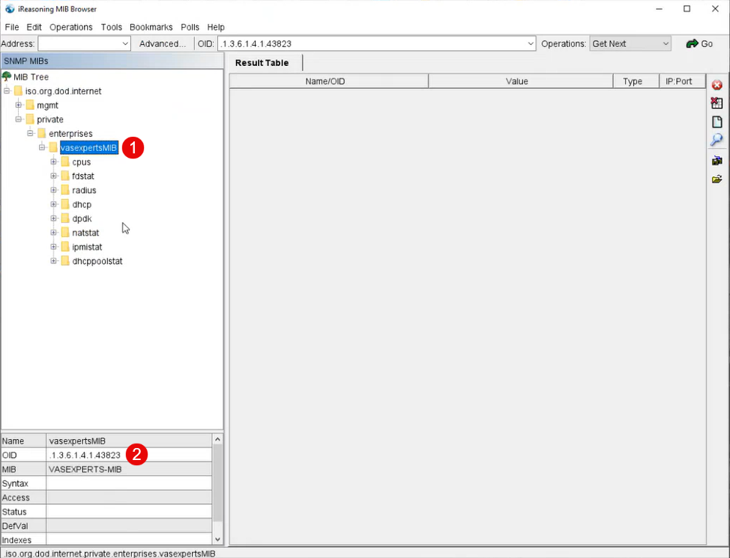

Known Limitations
On-stick device support available since version 13.2-beta4.2

