Monitoring via SNMP agent (Zabbix-agent)
We offer you the following set of parameters that can be taken from the SSG DPI:
- Errors in fastDPI process log /var/log/dpi/fastdpi_alert.log
- Errors in the /var/log/messages system log
- Losses (Drop) on dna interfaces
- Traffic volume on interfaces
- Availability of control interfaces
- Number of HTTP and HTTPS requests processed
- Number of blocked resources by HTTP, HTTPS, IP
- Number of PPPoE sessions
You can use Zabbix Agent for monitoring.
Current and final supported version of agent and server is 6.0, Zabbix agent 1 should be used. For newer versions of Zabbix, monitoring will be done via SNMP.

Agent Setup
- Install Zabbix agent 1 on the DPI server according to the instructions on the Zabbix website.
In the first step, select the following values:
  - Zabbix Packages
  - Zabbix version: 6.0+
  - OS distribution: CentOS
  - OS version: 8 STREAM
  - Zabbix component: AGENT
- Edit the configuration file /etc/zabbix/zabbix_agentd.conf: change the parameters Server= and ServerActive= to your server address, hostname= to the server hostname.
- Change the context of the /var/log/dpi/fastdpi_stat.log file:
chcon unconfined_u:object_r:zabbix_log_t:s0 /var/log/dpi/fastdpi_stat.log
- Open tcp/udp ports 10050 and 10051 in firewall
- Upload the ssg_userparams.conf file to the /etc/zabbix/zabbix_agent.d/ directory
- Edit the ssg_userparams.conf file by replacing the interface number in UserParameter
02-00.0 should be replaced with the interface names of your server!
The name must match the DPI config. If you have more than 2 interfaces in use, you must add a line similar to the existing parameters.
UserParameter=dpi.02-00.0.drops,tac /var/log/dpi/fastdpi_stat.log | sed /'IF 02-00.0'/q | tac | sed -e 1,/'Actual Stats'/d | sed '6!D' | awk '{print $1}' | sed 's/^.//'
- Restart the agent: systemctl restart Zabbix-agent

Server setup
- Install and configure Zabbix servers according to the instructions on the official website.
- Add template zbx_export_templates.xml
1) Go to Configuration section
2) Templates section
3) Click “Import”
4) Import template file
5) Save changes
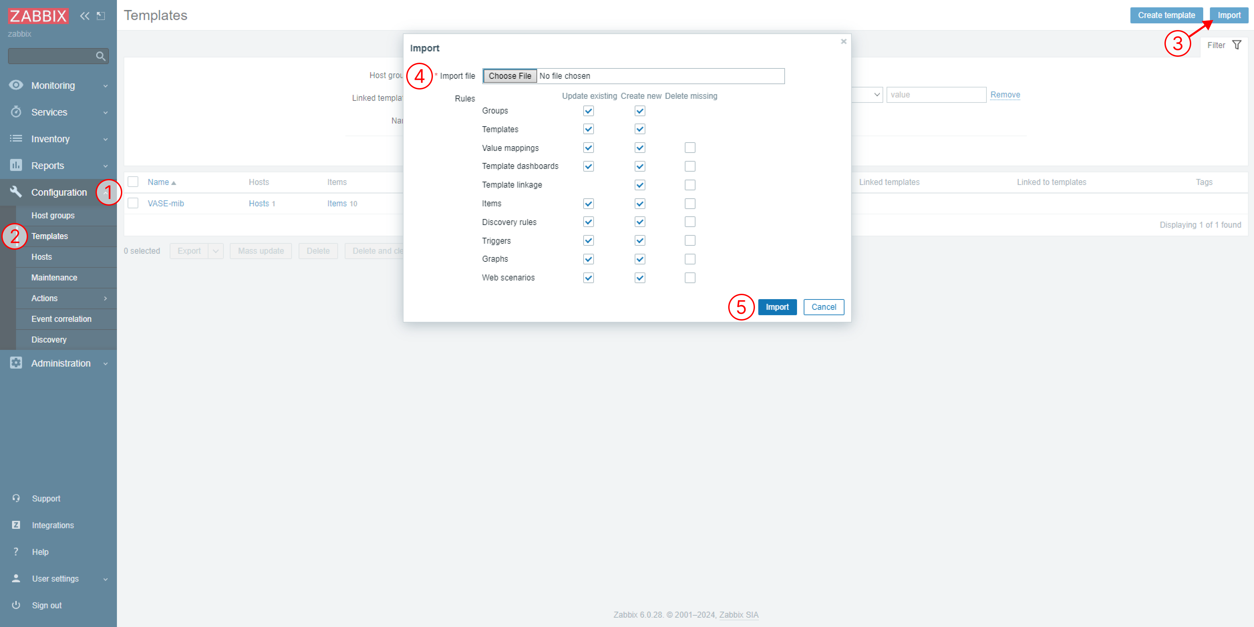
- Add a DPI server as a host
1) Go to Monitoring section
2) Hosts section
3) Click “Create host”
4) Set the required parameters, hostname, group and the previously added template
5) Save changes
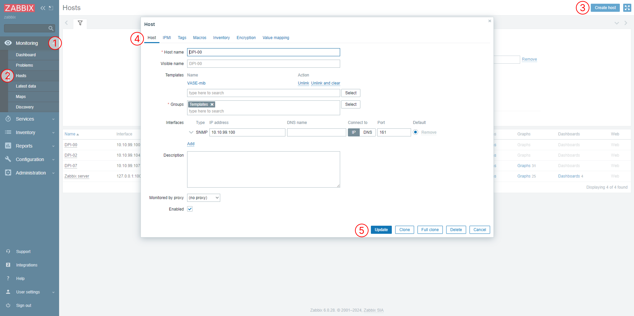
- Edit the template: change the names of the interfaces and keys so that they match the UserParameter.

