Database user configuration
The user "default" and an empty password are used to connect to the Clickhouse database by default.
You can set a user and password if necessary.
In the /etc/clickhouse-server/users.xml file on the server where QoE Stor is installed in the <users> section
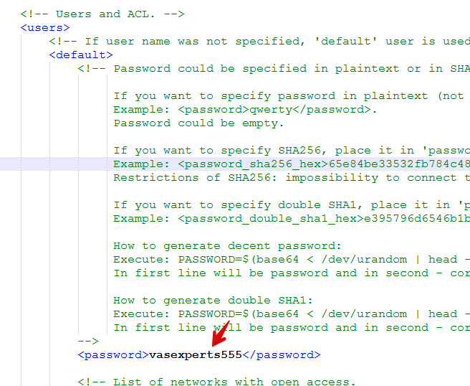
- Set a password for the default user
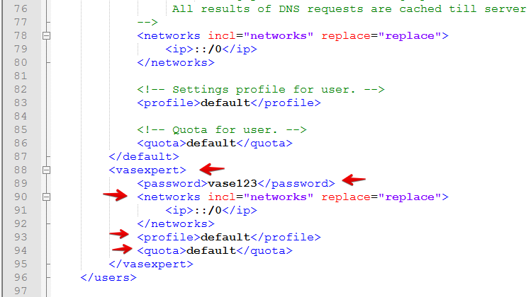
- Add a user, for example <vasexpert> and set the parameters networks, profile, quota the same as for the default user
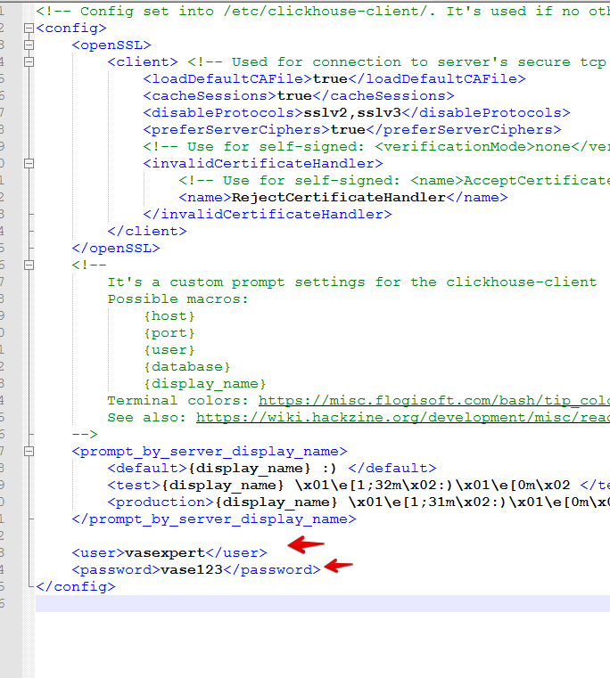
In the /etc/clickhouse-client/config.xml file in the <config> section add the <user> and <password> parameters
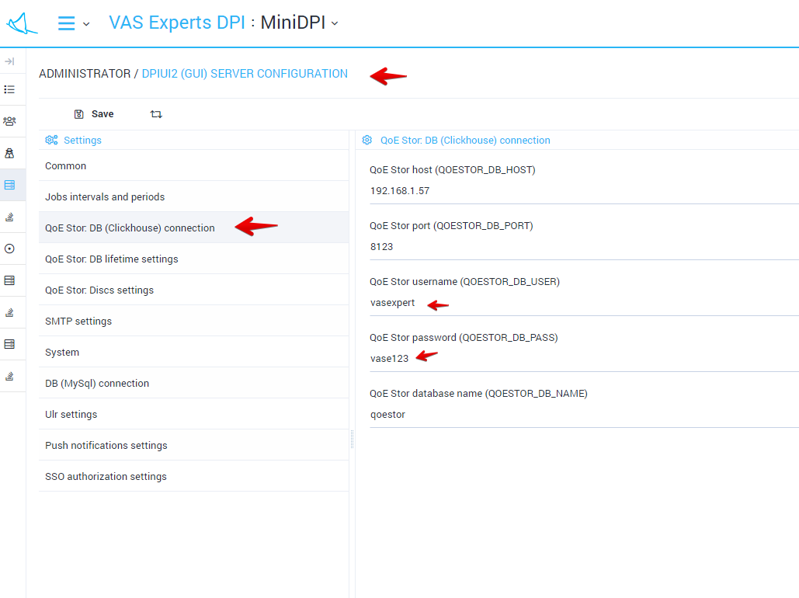
In dpiui2 in the configuration section, set the username and password to connect to the Clickhouse database

