DPI Configuration

Export Configuration
The DPI platform version must be at least 8.1!
IPFIX export is configured in the fastdpi.conf file on the DPI.
netflow=8
netflow_dev=em1
netflow_timeout=10
netflow_full_collector_type=2
netflow_full_port_swap=0
netflow_full_collector=YOUR_QOESTOR_IP:1500
ipfix_dev=em1
ipfix_tcp_collectors=YOUR_QOESTOR_IP:1501
A fastDPI restart is required for the changes to take effect.
The netflow parameter is a bitmask and can have multiple values. See more in section Configuring service.

Configuration in DPIUI2
The DPIUI2 version must be at least 2.1.0!
- Go to the SSG control → Configuration section.
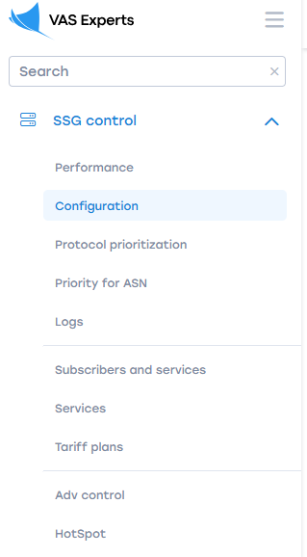
- Navigate to the tab "Collection and analysis of statistics on protocols and directions" and apply the following settings:
  - Set the neflow parameter to "Export full session statistics"
  - Set the netflow_full_collector_type parameter to "Export ipfix to tcp header"
  - Enter the socket of the fullflow receiver in the netflow_full_collector parameter
  - Leave the netflow_full_port_swap parameter empty or set it to "Preserve original port numbers".
- Navigate to the "PCAP Recording, IPFIX Export (Clickstream and metadata: SIP, FTP)" tab
  - Enter the clickstream receiver socket in the ipfix_tcp_collectors parameter.
- Save the configuration
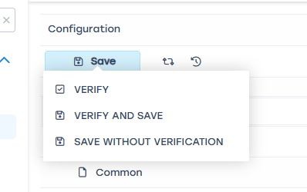
- Restart the DPI
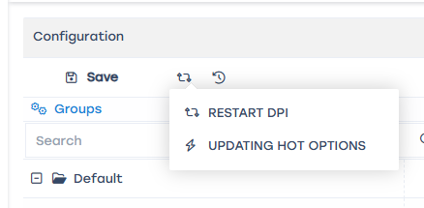

Assigning a DPI Number
- Go to the Administrator → Equipment.
- For each device, enter the Id on IPFIX collector.
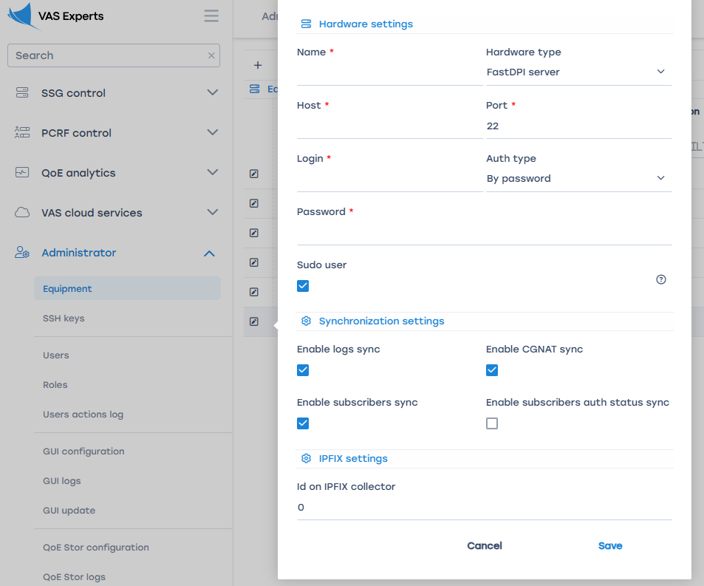

Configuring DPIUI2 Connection to QoE Stor
To view QoE reports, you need to configure the connection between DPIUI2 and QoE Stor.
See more in the section Connecting to QoE Stor Configuration

