Service OpenCellID
In the case of lat and lon coordinates in the gtp_cells_locations_dic catalog for cell towers, it is proposed to use a service to enrich the SSG GUI catalog with data about cell towers from an external source by API.
OpenCellID is a collaborative community project that collects GPS positions of cell towers and their corresponding location area identity. OpenCellID publishes an aggregate data set of cell locations licensed under a Creative Commons Attribution-ShareAlike 4.0 International License with the intention of promoting free use and redistribution of the data.
In order to activate service you need to add in
/var/qoestor/backend/.env
Parameters:
#Enables autoload of OpenCellID catalog
CELL_TOWER_AUTOLOAD_ENABLED=1
# 0 - Disabled (default)
# 1 - Enabled
#Token in LocalAPI platform
CELL_TOWER_LOADER_API_TOKEN=pk.fce9af82655c117ef42c88d36885cc8b
#Level of log
CELL_TOWER_LOG=1
# 0 - Info
# 1 - Debug
#Time interval to update empty data cell towers for report of geo position
CELL_TOWER_RESPONSE_HOUR=
#In hours
Token access by https://my.unwiredlabs.com/trial. After registration, the token will be available:
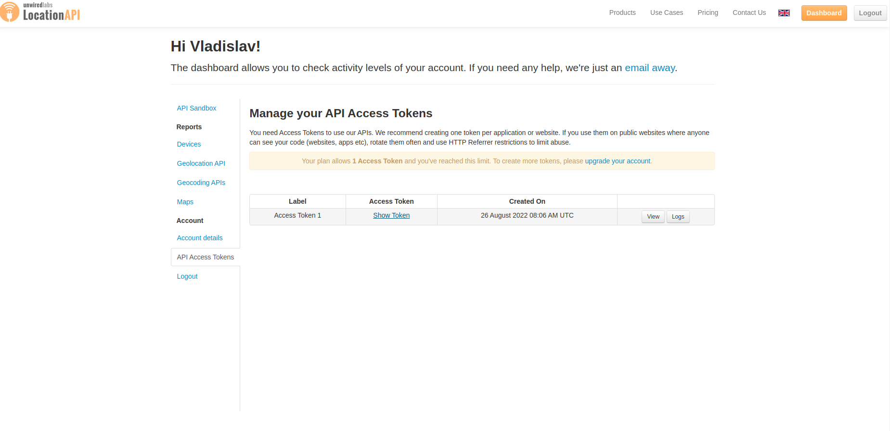
The link Show token is free token with 100 response per day limit.

