QoE Stor installation
Before installing or upgrading, check your Internet connection. Make shure you run scripts under the root or using sudo.
Check if the time and time zone are set correctly on the server. Correct and restart the server if necessary.
Do not disable the standard firewall-cmd. The installation script uses it for self-configuration.
Do not use the yum update fastor command. Install/update with the script below.
Enable IPv6. If the database doesn't start after installation, the most likely reason is IPv6. Check the error log: tail /var/log/clickhouse-server/clickhouse-server.err.log - the cause is usually clearly indicated there.
For automatically installation or upgrading follow these steps:
- Execute fastor-rpm_install.sh script.
source <(curl https://vasexperts.ru/install/fastor-rpm_install.sh)
It will cause the installation of the following packages: ipfixreceiver, clickhouse, fastor. All of them will be automatically configured according to the defaults.
- Restart your ssh terminal. You need to make command aliases available.
- Run the command
fastor-db-scheme
The database schema will be updated.
In some systems, the database starts very slowly (from several minutes to several tens of minutes, especially in systems with long-term data storage) and when updating you may receive an error like ERROR: while updating DB scheme
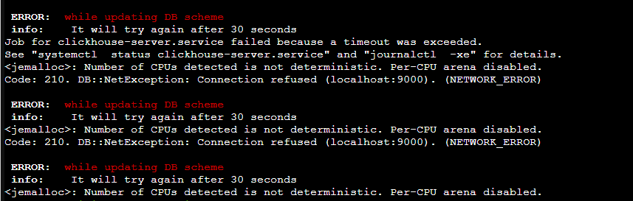Wait for the database to start. You can check the tail /var/log/clickhouse-server/clickhouse-server.log logs, or simply try to launch the clickhouse-client client - if there is a connection, then the database has started and is ready for connections.
After starting the database, run the command
fastor-db-scheme
Do not forget to execute
fastor-db-scheme
after installation. This insures cases when the schema does not have time to update as a result of a long restart of the database.

