General Description
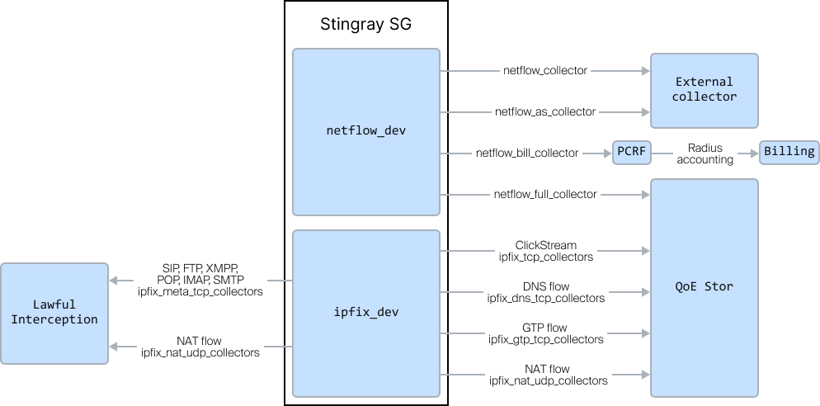
SSG supports statistics export for the following main data streams:
- NetFlow by protocols — protocol-related information. Protocol numbers are transmitted according to the reference guide,
- NetFlow by directions — information on Autonomous System (AS) numbers. AS numbers are transmitted according to the reference guide,
- NetFlow for billing (RADIUS accounting) — information on the volume of transmitted data per subscriber. This stream is sent to fastPCRF and converted into RADIUS accounting,
- Full NetFlow — complete (unsampled) data for each subscriber with additional fields for QoE (RTT, retransmissions) and NAT flow. Additional fields are available only for the IPFIX format (NetFlow v10).
Full NetFlow can be exported in one of the following formats:
- IPFIX (NetFlow v10),
- NetFlow v5.
For receiving, processing, and storing NetFlow, we recommend using the QoE Store statistical data collection software and the DPIUI2 graphical interface.
IPFIX export for the implementation of Lawful Interception (LI):
- ClickStream — users' web requests. Use cases in the QoE module: Subscriber analytics
- Protocol metadata: FTP, SIP, XMPP, POP, IMAP, SMTP
Additional data streams for IPFIX export:
- NAT flow - NAT flow export
- GTP flow - export of GTP-C signaling information for mobile networks to implement Location-Based Services

