Using DPI for optimizing large data transfers
With the growth in the number of users and the increase in speed in tariff plans, the issue of significantly expanding traffic storage systems arises over time. SSG allows reducing the volume of traffic mirrored to the storage system by optimizing and filtering large volumes of data (heavy content), such as p2p (torrent), video in HD and Full HD formats, data from streaming services and video hosting. The approximate percentage of traffic optimization ranges from 20% to 70% depending on the traffic structure and the list of protocol signatures optimized for filtering.
Features of purchasing a license for optimizing large data transfers:
- A BASE license is required for traffic optimization
- Installation scheme — mirror
- The license throughput is determined by the total traffic, rules are described in the Licensing section
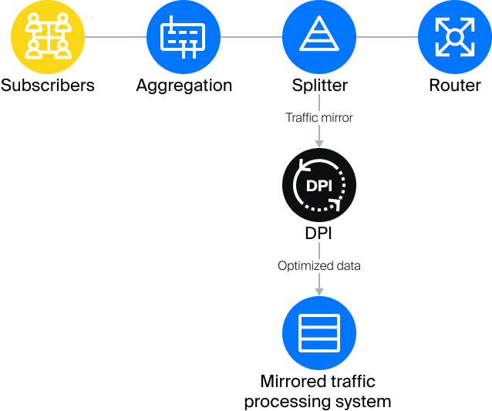
Usage scheme:

Example 1: One input interface and one output (01-00.0 → 01-00.1)
Define interface parameters in the configuration file /etc/dpi/fastdpi.conf:
in_dev=01-00.0
out_dev=01-00.1
only_tcp=0
mem_preset=1
Create the protocols.dscp file:
echo "bittorrent drop" > protocols.txt
cat protocols.txt|lst2dscp /etc/dpi/protocols.dscp
Full list of protocols.
Checking Filtering Results:
Execute
tail -200 /var/log/dpi/fastdpi_stat.log
In the statistics lines, find the percentage and volume of filtered traffic:
IF 01-00.0 :
...
Drop: [8054507798 bytes][68.92 %]
[9406449 pkts ][67.16 %]
...

Example 2: Two input interfaces and one output (01-00.0 and 01-00.1 → 01-00.2)
Define interface parameters in the configuration file /etc/dpi/fastdpi.conf:
in_dev=01-00:01-00.1
out_dev=01-00.2:01-00.2
only_tcp=0
mem_preset=1
Check Filtering Results:
Execute
tail -200 /var/log/dpi/fastdpi_stat.log
In the statistics lines, find the percentage and volume of filtered traffic
On 01-00.0:
Drop: [29472283528 bytes ][69.20%]
On 01-00.1:
Drop: [31027588123 bytes ][68.27%]
Configuration:
root@dpi dpi]# dscp2lst / etc / protocols.dscp | grep drop
https drop
oob-ws-https drop
llsurfup-https drop
compaq-https drop
jpegmpeg drop
wap-push-https drop
appserv-https drop
wbem-https drop
wbem-exp-https drop
sun-sr-https drop
plysrv-https drop
pcsync-https drop
https-wmap drop
armcenterhttps drop
tungsten-https drop
amt-soap-https drop
commtact-https drop
Bittorrent drop
AVI drop
Flash drop
MPEG drop
QuickTime drop
smc-https drop
oracleas-https drop
sun-user-https drop
synapse-nhttps drop

