General description
The ad content replacement or blocking option allows to modify selectively the content on WWW pages that contain advertising banners. This service can be individually configured for each subscriber.
Application examples:
- Commercialization of free WiFi access points.
- Social Internet.
- Ad content blocking service for subscribers.
How it works:
- A subscriber visits the page //http://www.popularsite.com//.
- Stingray SG detects by the loaded list that the page contains links (URL) to ad content. It redirects requests for this content to operator's WWW site //http://mybannersite.com// for another ad content1).
For example: //http://an.yandex.ru/system/context.js// - Yandex Direct Ads, or
//http://popularsite/flashbanner.swf// - flash banner of the original site.
- The operator's WWW site //http://mybannersite.com// returns a banner or advertisement or another ad content according to the requested URL. This link has a format: //http://www_opewrator's_site/original_host/original_link//.
For the example considered, it is //http://mybannersite.com/an.yandex.ru/system/context.js// or //http://mybannersite.com/popularsite.com/flashbanner.swf//2)
- The subscriber receives the new ad content as a part of the requested page.
General scheme:
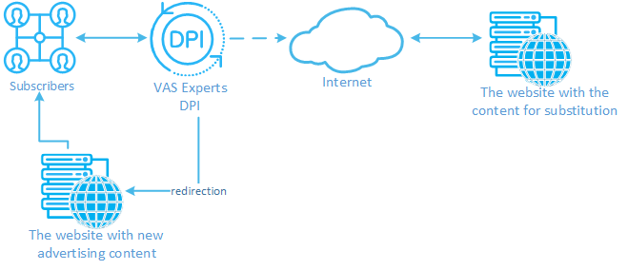
Required components:
- Deep Packet Inspection (DPI) platform.
- WWW site with a new content.
Integration with ad content delivery systems is handled by an operator based on samples and the present manual. Ready-to-use solution is scheduled to be available in the next versions.

1)The original ad content link (URL) on the site is not modified.
2)The link would be //http://mybannersite.com/block/an.yandex.ru/system/context.js// in case the ad blocking option is enabled for this subscriber.

