Components and Interfaces
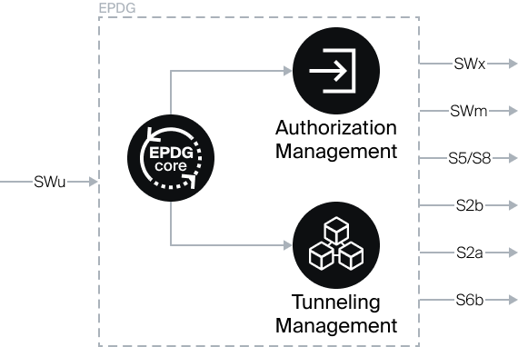

Logical Components of SSG ePDG
- ePDG Core — the main component responsible for coordinating modules and managing tunneling parameters, ensuring QoS;
- Authorization Module (AM, Authorization Management) — manages authorization interfaces, with flexible scenario settings for integration with the operator's IS. Responsible for interaction with the operator's AAA server if available or can completely replace it for internal and external services;
- Tunnel Management Module (TMM, Tunneling Management) — manages the binding of IPSec and GTP tunnels. Responsible for interaction with the operator's PGW, with flexible configuration scenarios for working with different interfaces.
In the SSG ePDG, a single fast-epdg process is responsible for the operation and interaction of all logical components.

Supported Interfaces
Input
SWa (SWm) | For external systems, such as TWAG. Applied in AAA-proxy case
SWu | From UE
S6b | From operator's PGW, for organizing flow from PGW to HSS on incoming call
Output
SWx | To HSS
SWm | To AAA
S2b | To PGW for signaling traffic
S5/S8 | To PGW for signaling traffic (when S2b is unavailable)
S2a | To PGW in TWAN mode

