Integration Cases of SSG ePDG with Operator's IS
To implement SSG ePDG it is required to set up interaction with the following systems of the telecom operator via Diameter protocol:
- AAA server - for authentication and authorization;
- HSS (only if AAA server is absent);
- PGW - for receiving signaling and voice traffic.
Below are several possible integration cases.

Authentication and Authorization
The authorization module (MA, Authorization management) of the SSG ePDG is responsible for authorization of the operator's subscriber. The settings and configuration of this module allow to support different integration scenarios depending on the interfaces that the operator is willing to provide.

Case 1. Authorization on AAA (Diameter protocol, SWm interface)
Conditions:
Operator's AAA operates via the standard SWm interface.
Process:
Authorization Management (AM) module requests authorization from Operator's AAA via SWm, then AAA interacts with HSS via SWx, and during a call, interacts with PGW via S6b.
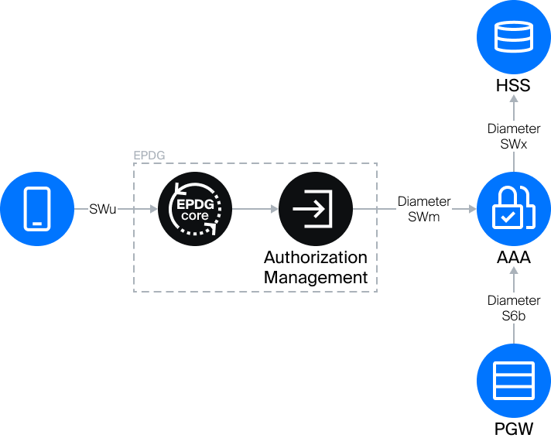

Case 2. Authorization on HSS (Diameter protocol, SWx interface)
Conditions:
The operator does not have its own AAA server; in this case, the AM obtains authorization directly from the Operator's HSS via SWx.
Process:
During a call, the AM replaces Operator's AAA: Operator's PGW queries it for authorization confirmation via the S6b interface, the AM queries HSS via SWx.
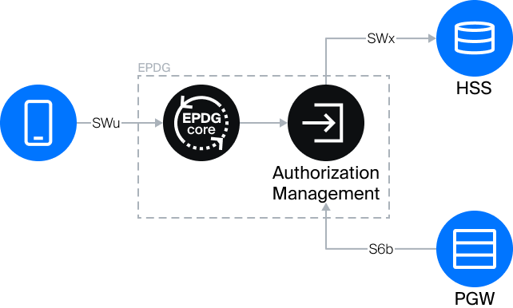

Option. AAA-proxy Mode (SWa (SWm) interface for External IS)
The operator does not have its own AAA server, but there is some IS, for which it is needed, for example, TWAN or another ePDG. In this case, SSG ePDG can accept requests via the SWm interface and perform authorization on HSS and PGW via standard SWx and S6b interfaces.

Tunneling
The Tunneling Management Module (TMM) is responsible for organizing tunnels between ePDG Core and Operator's PGW. Several cases can be implemented on the operator's side with its help.

Case 1. Work via Standard Interface (S2b interface)
Conditions:
Operator's PGW supports ePDG's native interface - S2b.
Process:
Signaling traffic from EPDG to PGW flows through the GTP-C tunnel via the native S2b interface. User Plane (voice traffic) flows through the GTP-U tunnel.
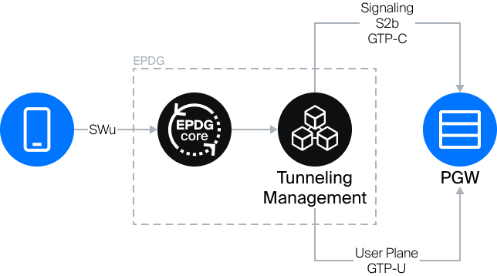

Case 2. SGW Emulation (S5/S8 interface)
Conditions:
Operator's PGW does not support S2b, only supports S5/S8.
Process:
In this case, TMM emulates the operation of SGW and communicates with PGW via the S5/S8 interface. User Plane (voice traffic) flows through the GTP-U tunnel.


