Five operator steps to launch WiFi Calling

Step 1. Integration of ePDG with Operator Systems
- AAA - subscriber authorization in the network
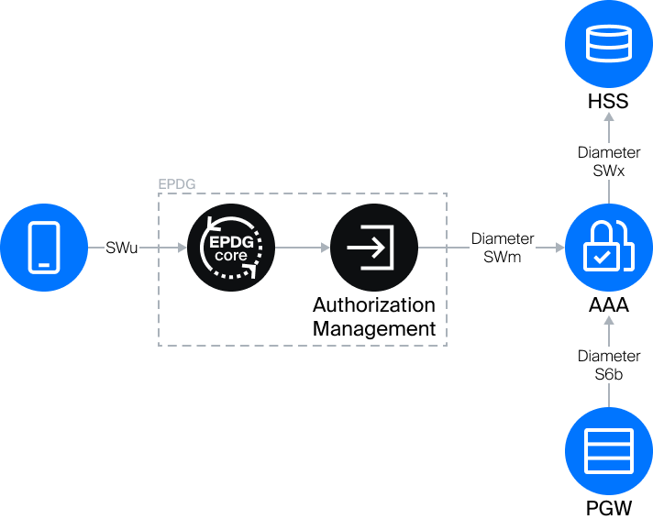
- PGW - organization of the GTP tunnel with ePDG, voice traffic routing
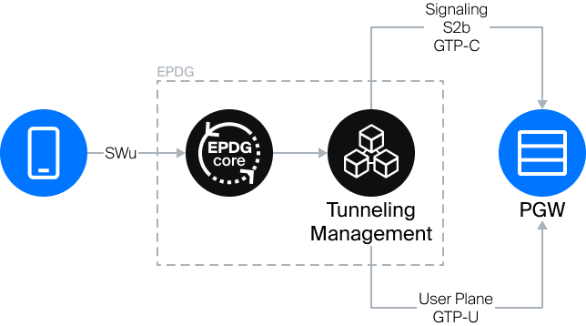
The VAS Experts solution implements various integration scenarios, including for MVNOs and small operators.

Step 2. Obtaining the ePDG Domain and Certificate
- To enable UE to work with ePDG, a domain for ePDG is required from the 3GPP association. To obtain it, you need to send a LoA file and a scan of the technical annex to 3gppnetwork.org_delegation@3gsma.com with the subject: Letter of Authorization for the transfer of the domain. The wait time is 1-2 months, and they will return a signed LoA and configure a subdomain like epdg.epc.mncXXX.mccYYY.3gppnetwork.org
- Obtaining a domain certificate is optional for additional protection.

Step 3. Enabling IMS
Enabling the IMS context on the network and allowing Voice-over-PS (VoLTE and VoWiFi) is required. For MVNOs, this requires interaction with the host operator and debugging the interaction. This can take 1-3 months.
If VoLTE is already launched by the operator, implementing VoWiFi is much easier.

Step 4. SIM Configuration
WiFi Calling may require changes to the SIM configuration. Generally, this can be done via OTA.
VAS Experts will provide SIM configuration rules.

Step 5. Enabling WiFi Calling on Phones
This is the longest part of the process; we recommend starting it immediately after deciding to implement ePDG.
Support for your operator with enabled VoLTE and VoWiFi options should appear in the phone and modem configuration (CarrierConfig). This can only be done by phone manufacturers (Samsung, Honor, Lenovo, and many others). Without support for your operator (by PLMN code on the SIM), the phone ignores these options.
- Interaction with each vendor occurs separately, with a total duration of at least 3 months. The vendor provides a questionnaire to the operator, creates an engineering firmware based on it, tests it on the operator’s network, then releases new devices with it and can add it to old ones via OTA.
- If the MVNO has its own PLMN, separate interaction with the vendor is required.
- In private networks, it is necessary to use SIMs with the operator’s PLMN with WiFi Calling support in CarrierConfig.
VAS Experts will help optimize the interaction process with vendors.
It is important that WiFi Calling only works on relatively new phone models, not the most budget models, with an operator's SIM that supports LTE. An approximate list of phones can be found on marketplaces with the WiFi Calling filter, for example, here.

