Description and cases
Filters in reports allow the user to filter data by certain criteria. This is convenient for quick search of necessary information in large volumes of data.
Report filtering takes place in the QoE sections of the analytics: Netflow, Raw full netflow, Clickstream, Raw clickstream.
Before applying filters to reports, you must select data by a specific time interval using the "Period" field:
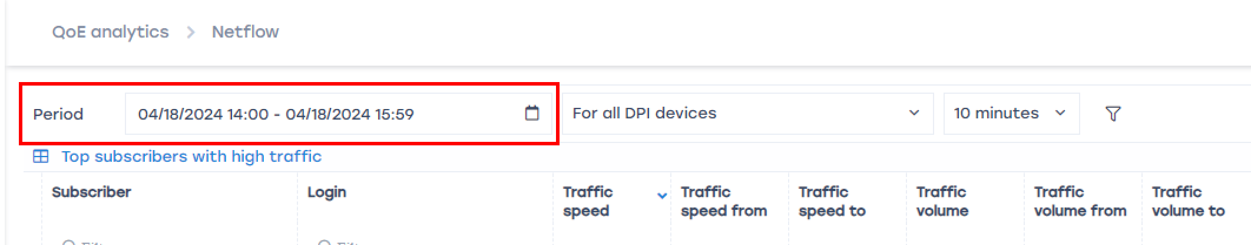
There are two options for selecting a period:
- Custom range — arbitrary Start and End of period, set manually;
- Quick ranges — ready-made date and time intervals, selectable from the list given.
All filters customized in the scripts below can be saved as profiles for quick application the next time you use the reports. Detail

Case 1. Searching for a subscriber in QoE
It is used if you need to track the activity of a specific subscriber, IP pool or subscriber list.
Search can be performed by IP or Login, if you can't find the required record by one filter - try another one.
Reports may also contain multi-subscriber - a single login that has been assigned multiple IP addresses or a range of IP addresses and CIDRs.
Detail.
1. Select filter. To search by IP - "Subscriber", to search by login - "Login";
2. Customize the filter by one of three options:
Single subscriber | IP:  Login:
Subscriber pool | IP:
Subscriber list | IP:  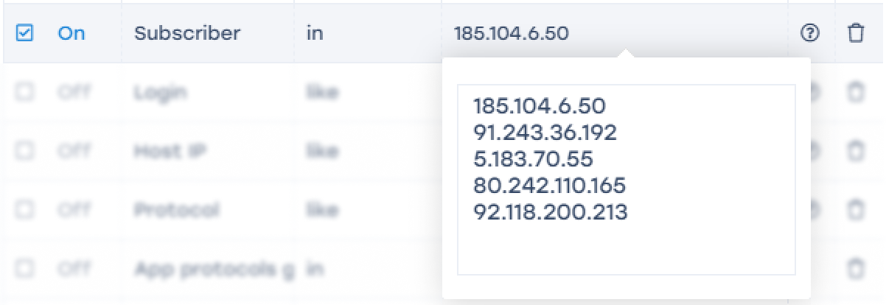  Login:  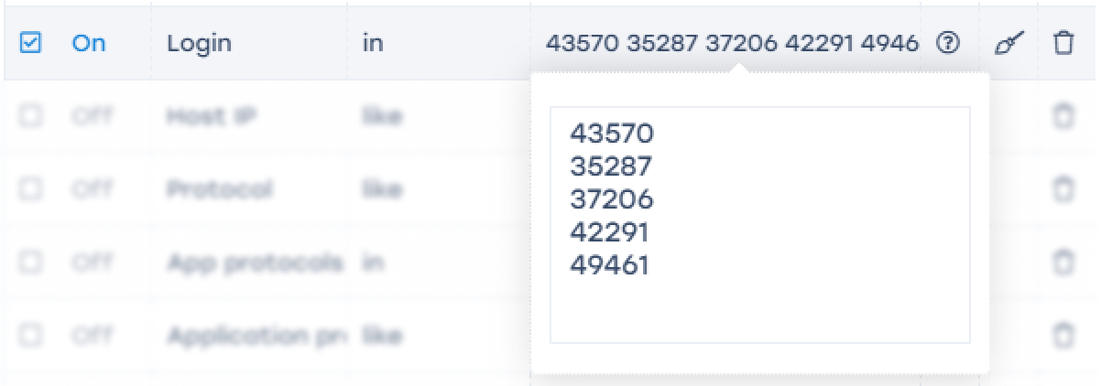
3. Enable the filter by checking the checkbox to the left of the filter to be configured;
4. Click "Apply".

Case 2. Filtering by resource
It is used if you need to find subscribers who have visited a specific resource or list of resources.
- Select the "Host" filter;
- Select the "=" or "like" operator;
- Enter the name of the resource;
- Enable the filter by checking the checkbox to the left of the filter to be configured;
- Click "Apply".
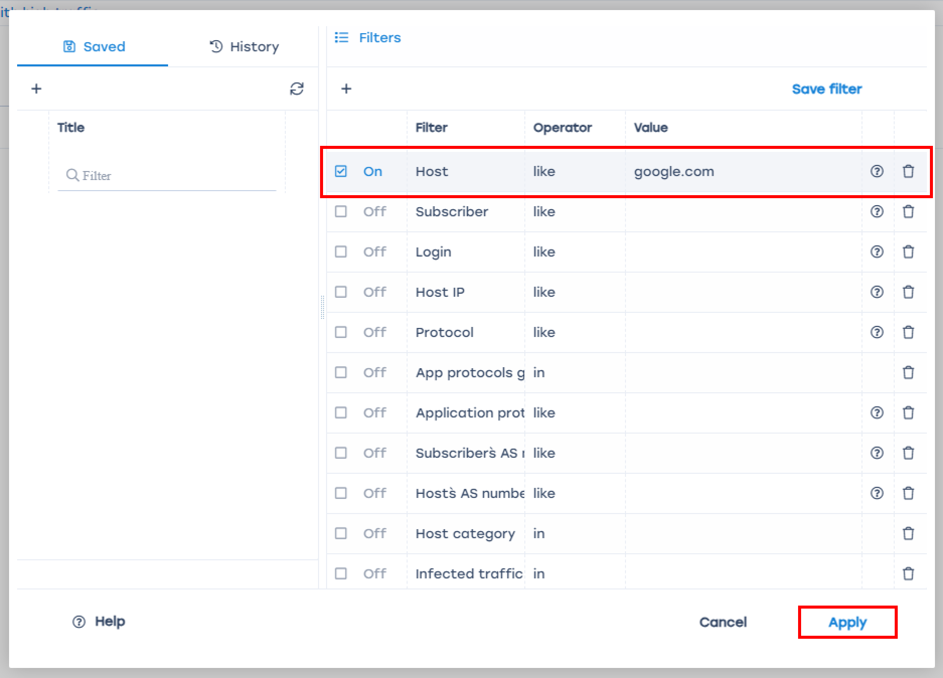
To filter by list of resources, follow the principle from Case 1. Searching for a subscriber in QoE → Subscriber list.

Case 3. Filtering by CIDR address
Used if you want to filter data by a specific IP address with a subnet mask.
- Select the "Subscriber" filter;
- Select the "in CIDR's" operator;
- Enter the IP address with subnet mask;
- Enable the filter by checking the checkbox to the left of the filter to be configured;
- Click "Apply".
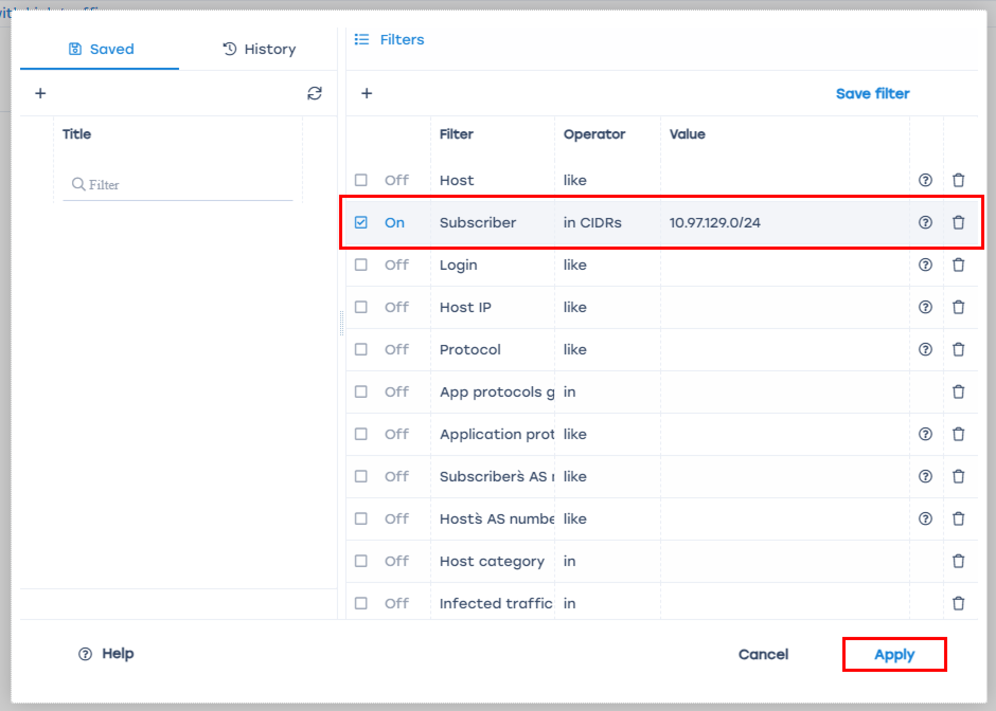

Case 4. Filtering by Application Protocol
This scenario applies if you need to find subscribers assigned a specific application protocol.
- Select the filter "Application Protocol";
- Choose the operator "=" or "like";
- Enter the protocol name;
- Enable the filter by checking the box to the left of the customizable filter;
- Click "Apply".
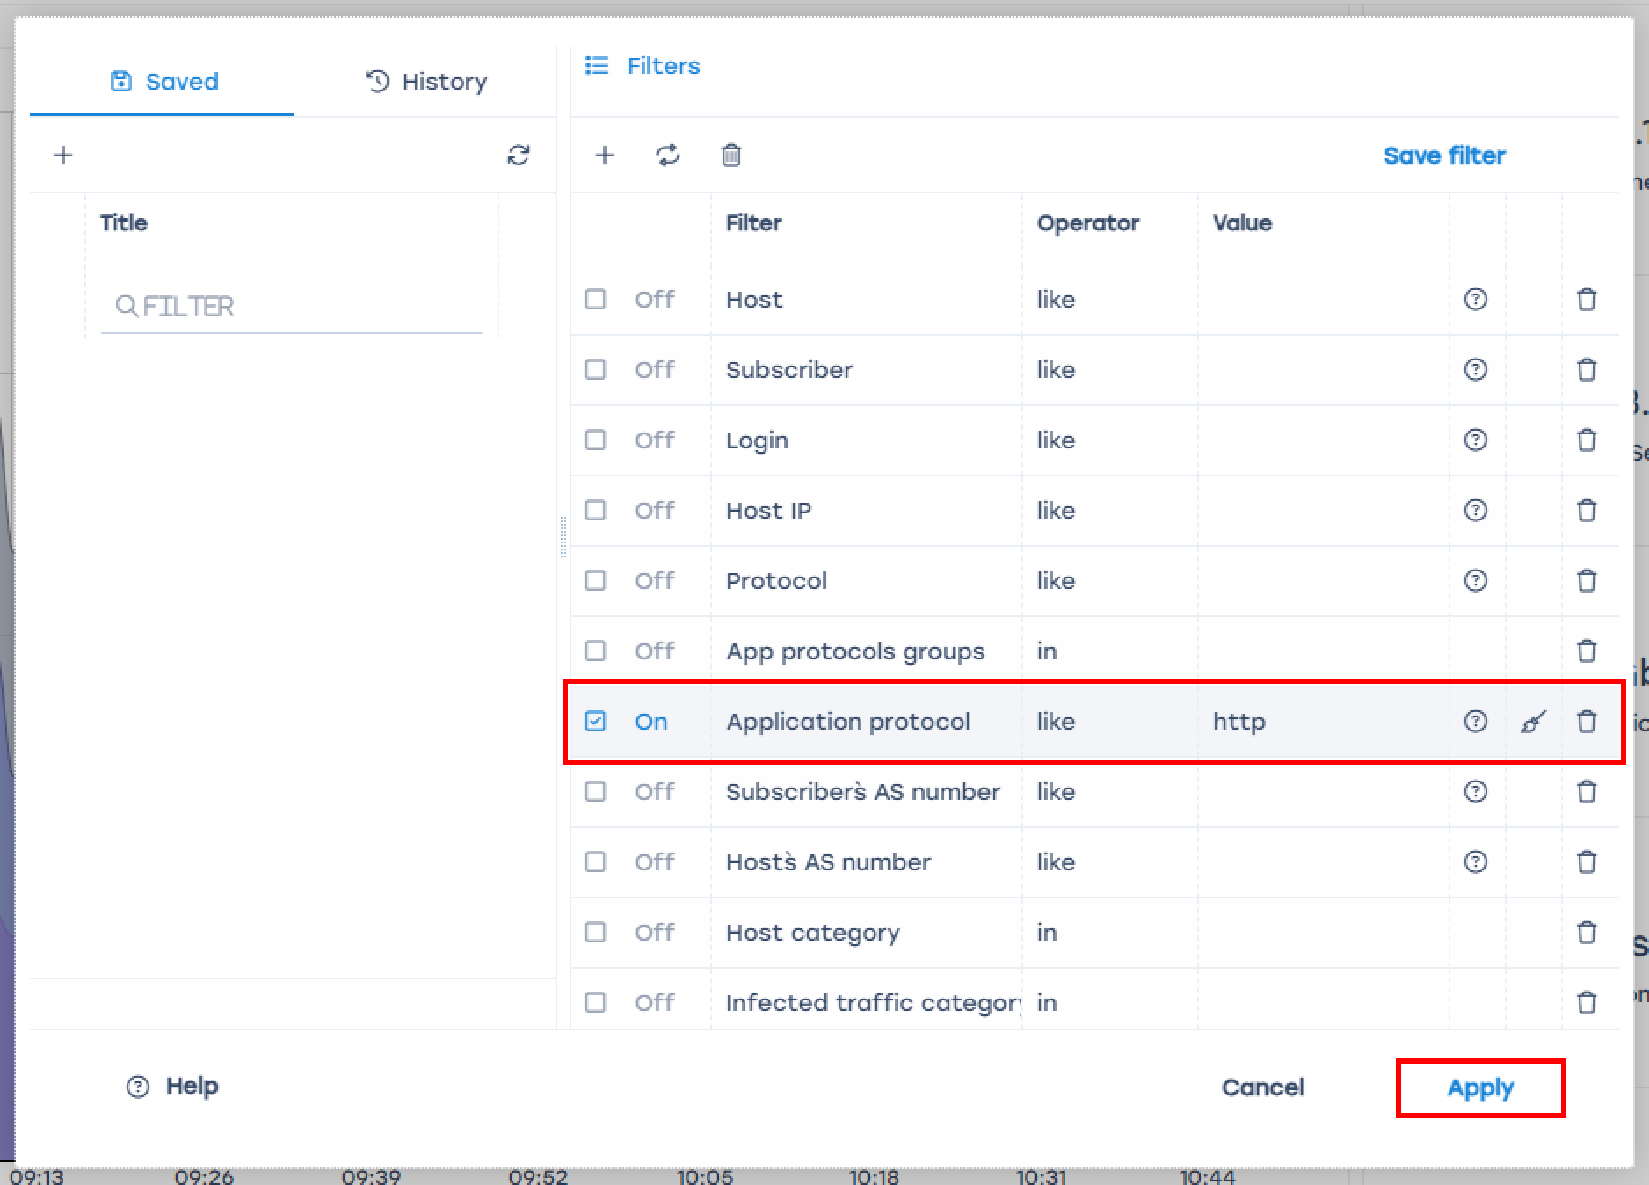
A description of all available filters by section and the operators applied to them can be found on the Filter and operator lists page.

