Saving Filter Profiles
The filters configured in the scenarios can be saved as profiles for quick application in future report usage. To do this:
- Click on "+" on the left side of the filter configuration window, under the "Saved" tab to create a profile and give it a name:
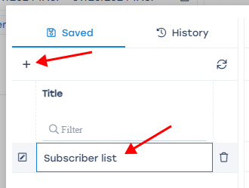
- Fill in the desired filters and mark them as enabled. Examples: Description and cases
- Click on the "Save Filter" button
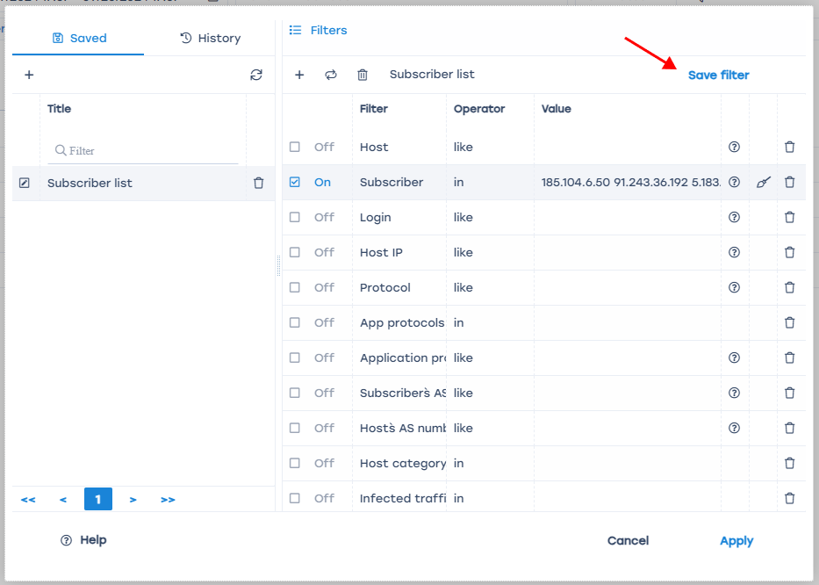
Filter profiles are saved within a single section. This means profiles created in the "NetFlow" section can be applied to all reports in that section, but will not be available in the "Raw Full NetFlow", "Clickstream", and other sections.
The description of all available filters by section and the operators applied to them can be found on the page Filter and operator lists

