Report Settings and Profile Saving
For convenience, you can limit the number of rows and columns displayed in the report table. To adjust these settings, click the gear icon below the table.
In the opened window, create a settings profile:
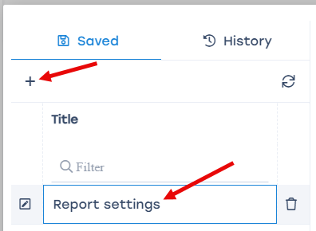
For a table report, you can modify:
- Column visibility;
- Row limit;
- Report name;
- Display filter;
- Page orientation.
- By clicking the Save settings button, you can add the modified settings to the list for quick application in future reports.
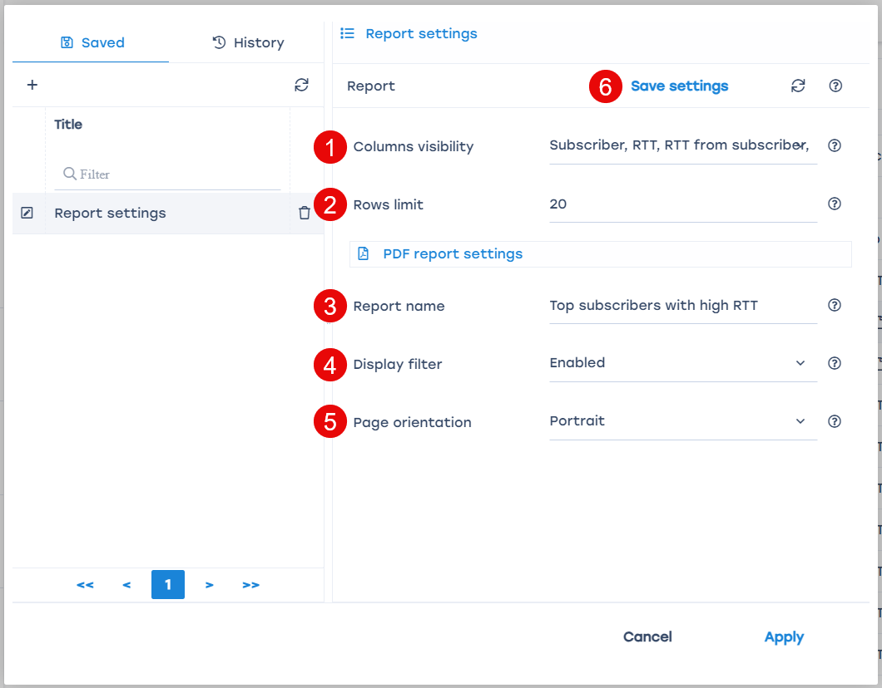
For a chart report, you can modify:
- Items visibility;
- Chart step;
- Chart type;
- Report name;
- Display filter;
- Page orientation.
- By clicking the Save settings button, you can add the modified settings to the list for quick application in future reports.


