Real-time subscriber traffic analysis
This use case is performed in "Online Reports" module.
The Live-view report is a way to monitor subscriber traffic in real time with an aggregation interval starting from 5 seconds. This report collects indicators that affect the assessment of subscriber connection quality: bandwidth, traffic speed, latency and packet loss, and top used protocols.
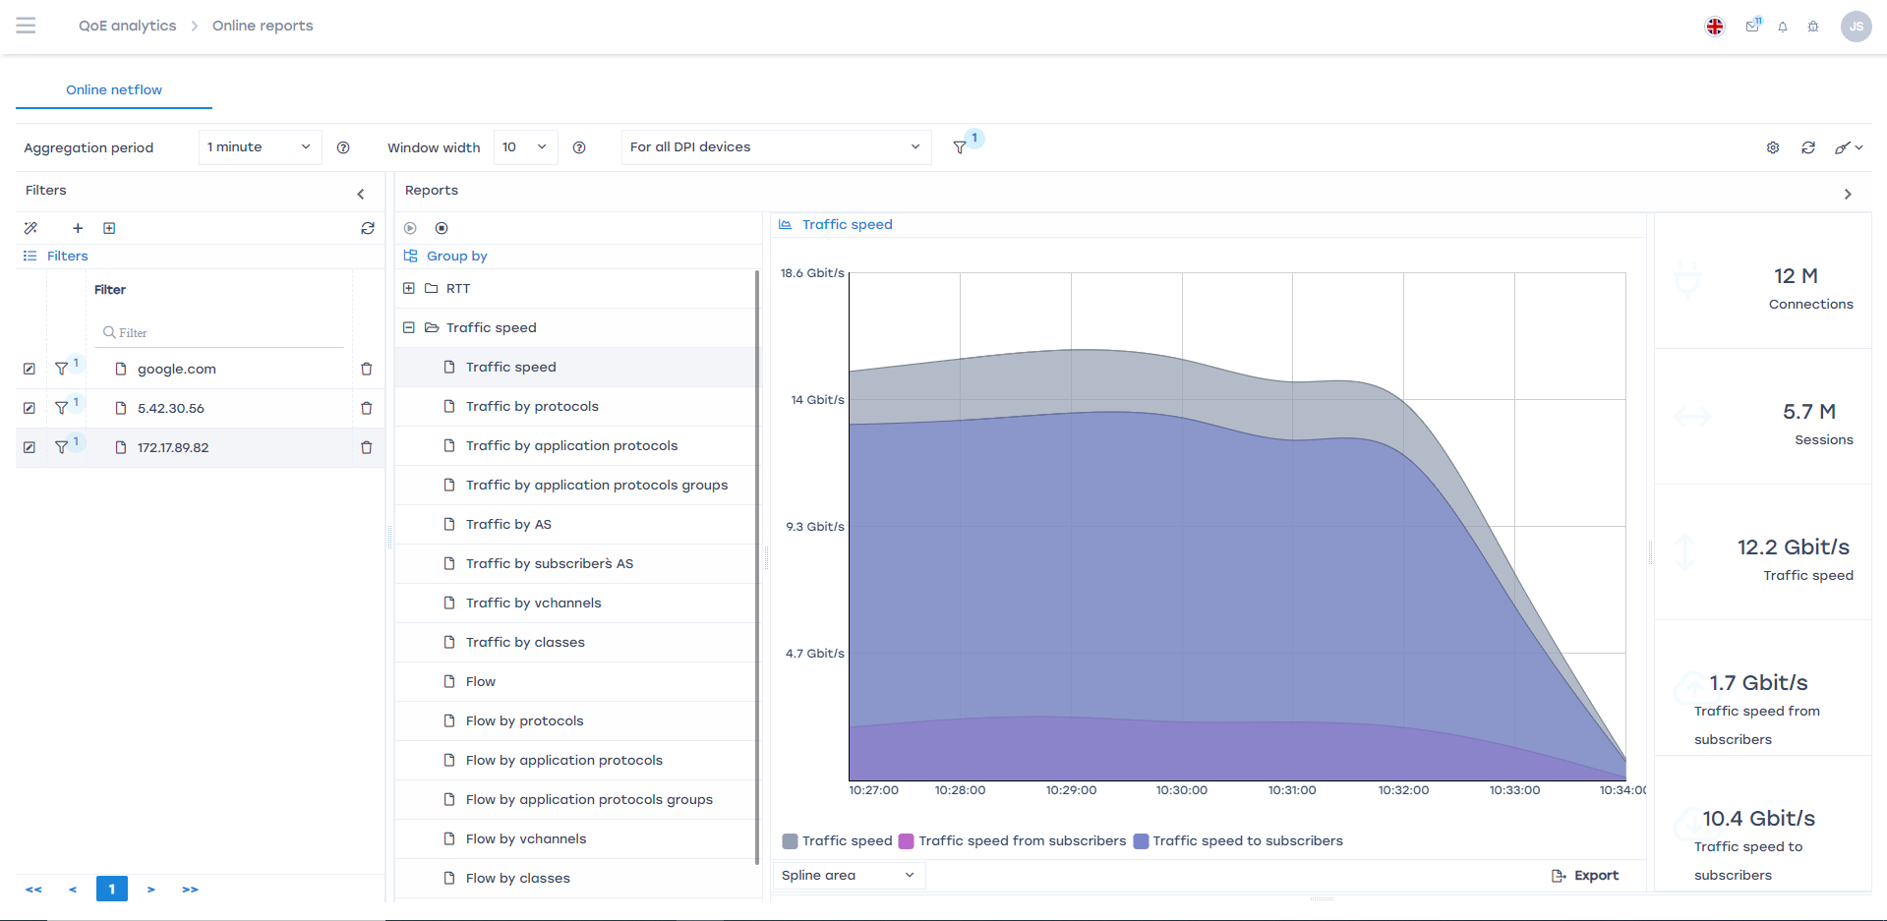
When a subscriber calls technical support, the specialist can check:
- whether the subscriber has sufficient bandwidth,
- how a specific web service is performing,
- whether torrent traffic is throttling streaming services,
- whether there is latency (RTT) within WiFi.
Detailed configuration of online reports is described here; for this use case, select the report “Traffic speed” → “Traffic speed.”
This functionality is available in the QoE Analytics module under the BASE license.

