ClickStream analytics
DPI exports information about all client web requests in IPFIX (NetFlow v10) format.

1. Detecting Internet service reselling
DPI exports unique UserAgents sent in HTTP requests. The QoE module aggregates information for each IP (or login, if used). The statistics record every phone and PC behind subscriber NAT. Usually, up to 30 unique UserAgents are detected per household — any number higher may indicate reselling the Internet connection to other apartments via the main router.
Steps to find such cases:
- Go to QoE Analytics → Subscribers → ClickStream
- Create a filter (use Shift+Enter to add entries) where:
- Mozilla – identifies PCs
- Dalvik – identifies mobile phones
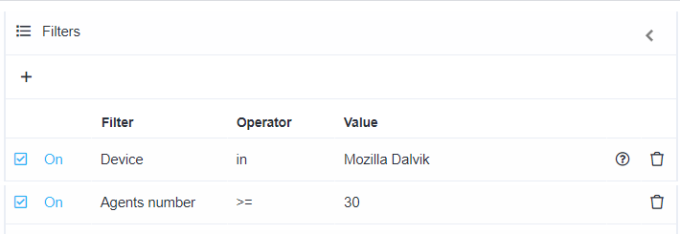
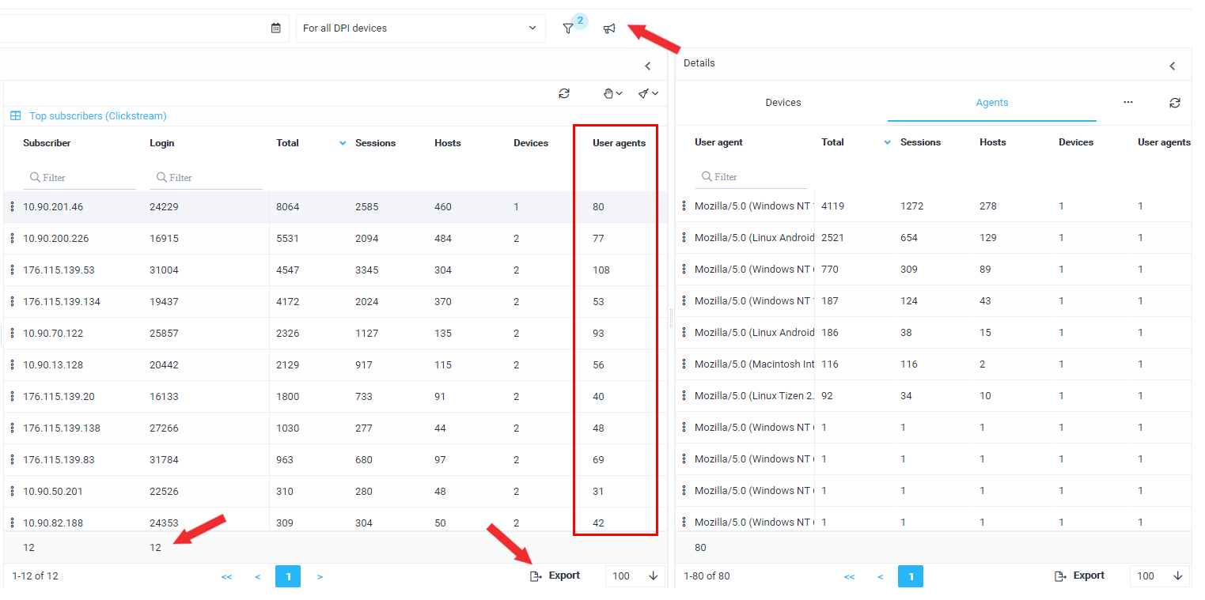
Interpreting the statistics:
- The filter shows 22 potential clients possibly reselling the service.
- More details about detected devices can be found in the "Details" window.
- Using the megaphone icon, you can add them to a marketing campaign and send browser notifications.
- Reports can be exported in a convenient format.

2. Churn prevention (detecting interest in competitors)
DPI exports ClickStream — all HTTP/HTTPS user requests on the Internet. The QoE module aggregates information per IP (or login, if used). The statistics include URLs for HTTP and domain names for HTTPS.
Steps to detect interest in competitors:
- Go to QoE Analytics → Subscribers → ClickStream
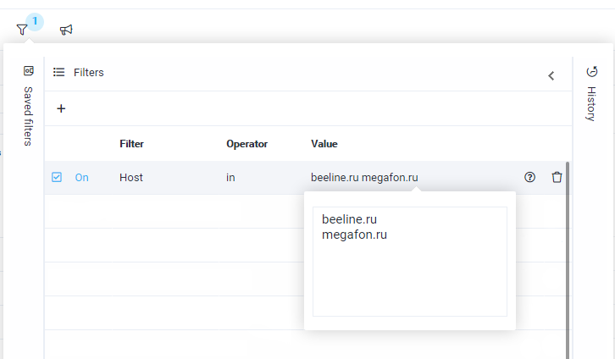
- Create a filter with competitor websites in your region
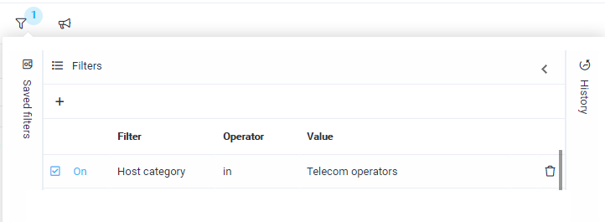
- Or use the “Telecom operators” category
Interpreting results:
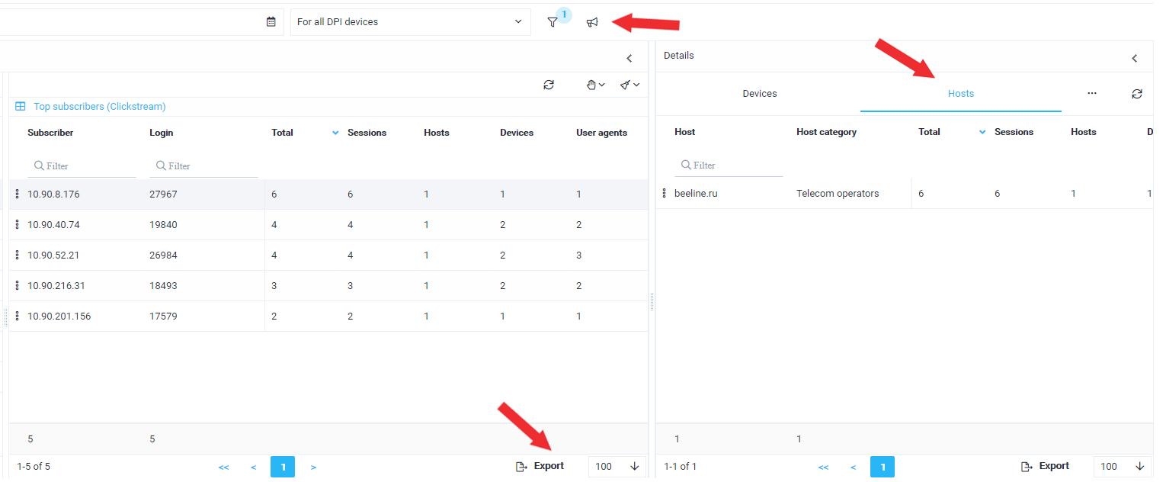
- The filter shows 10 potential clients interested in competitors.
- More details can be viewed in the "Details" window.
- Using the megaphone icon, you can add them to a marketing campaign and send browser notifications or satisfaction surveys.
- Reports can be exported in a convenient format.

3. Detecting Smart TV devices
DPI exports unique UserAgents sent in HTTP requests. The QoE module aggregates information per IP (or login, if used). The statistics include each Smart TV detected behind subscriber NAT.
Steps to detect Smart TVs:
- Go to QoE Analytics → Subscribers → ClickStream
- Create a filter using math and enter a regular expression `(?i)(\W|^)(smart|LG|samsung)(\W|$)` to find specific devices:
- smart
- LG
- samsung
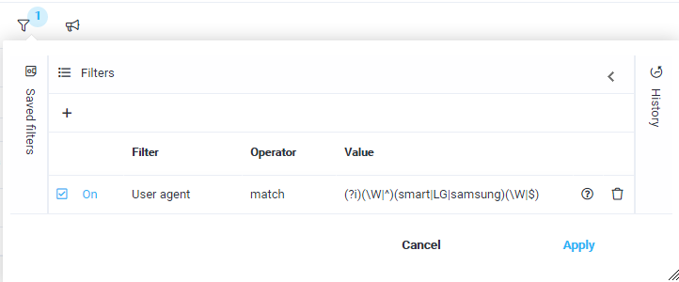
Interpreting results:
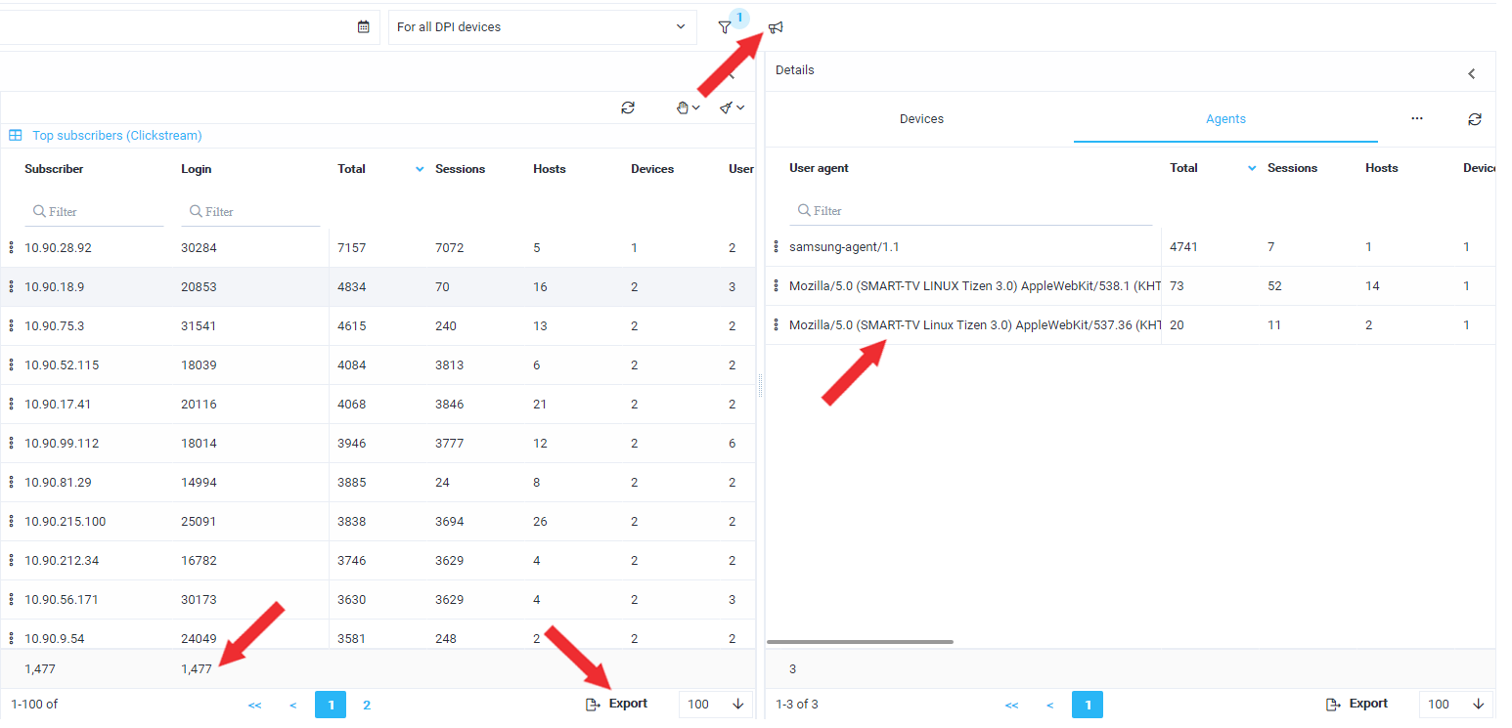
- The filter shows 893 clients with such devices detected.
- More details can be viewed in the "Details" window.
- Using the megaphone icon, you can add them to a marketing campaign and send browser notifications or satisfaction surveys.
- Reports can be exported in a convenient format.

4. Subscriber profiling by interests
ClickStream allows identifying clients’ usage of popular services or interest in certain website categories.
QoE Stor provides a categorized list that includes resources divided into 54 categories.

OTT services usage
Steps to find:
- Go to QoE Analytics → Subscribers → ClickStream
- Create a Host filter, use math and enter the regular expression `(?i)(\W|^)(smotreshka|ivi|okko|netflix)(\W|$)` to search for OTT services:
- smotreshka
- ivi
- okko
- netflix

Example: segmenting the subscriber base
Steps to find:
- Go to QoE Analytics → Subscribers → ClickStream
- Create a Host category filter, use the desired category:
- Auto
- Kids websites, etc.

Example: finding subscribers with high traffic usage
Steps to find:
- Go to QoE Analytics → NetFlow → High traffic top (right side) → Top subscribers
- Sort by traffic volume

